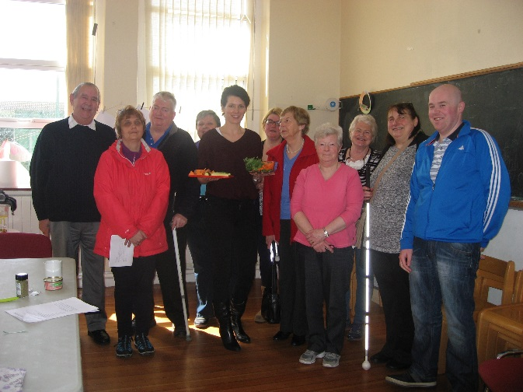
Health and Wellness Training in Limerick
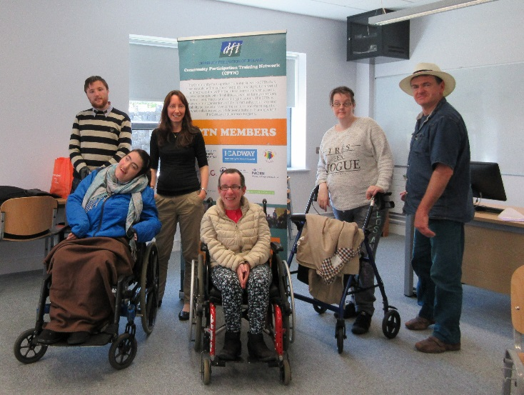
Practical Self Advocacy Training in Galway

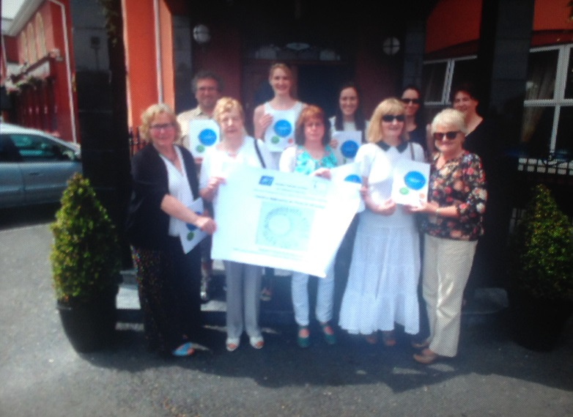
CPTN Members

CONTENTS

Executive Summary and Recommendations | Page 2
Background: Development of the Community Participation Training Network | Page 8
Chapter 1: Community Participation Training Network - Impact and Effectiveness | Page 21
Chapter 2: Community Participation Training Network (Training) - Impact and Effectiveness | Page 28
Chapter 3: The Impact of Community Participation Training Network for Policy and Practice | Page 42
Chapter 4: Future Planning and Development of the Community Participation Training Network | Page 46

Executive Summary and Recommendations

Background

This evaluation report documents and assesses the achievements of Community Participation Training Network and reviews its potential as a model of good practice that could inform wider policy and practice.

The evaluation report is based on a series of interviews, observations and documentary analysis, which include Network participant’s observations and evaluation comments, interviews with members of the Community Participation Training Network and participants of the ‘project’.

Background to Community Participation Training Network
The development of the Local Government structures presents a vibrant policy landscape and provides a practical model for interface with local government. It seeks to ensure that the views of all those involved are communicated within the relevant Local Authority structures and that all member organisations are fully up to date with developments in all of these Local Authority structures. This has the potential to lead to enhanced awareness of issues, sharing of ideas, solutions and opportunities for greater co-operation across sectors and organisations for the greater benefit of the community.
However, many concerns have been voiced in the community and voluntary sector that these structures also pose a number of barriers to participation. The Community Participation Training Network was therefore created within the context of local government reform framework and the development of Public Participation Networks (PPNs).
The specific aims of the Community Participation Training Network included:
- To support the capacity of and direct representation of people with disabilities within local community structures.
- To provide advocacy training to members of the network.
- To train people with disabilities to become community representatives.
- To facilitate networking opportunities, peer-support and sharing of information between network members.
- To build alliances between people with disabilities and other community representatives .

In December 2014 the Disability Federation of Ireland made an application to the Training Links Grant Programme 2014 - 2016 on behalf of ten interested members and successfully engaged funding commencing work in early 2015.
Activities of Community Participation Training Network 2015 - 2016
In order to achieve these aims the Community Participation Training Network sought to use a variety of methods to increase consciousness of exclusion and its possible solutions at the ‘new’ local government policy making level, to help break down stereotypes of the excluded, and to promote values associated with inclusion.

The Community Participation Training Network provided a network structure of a range of disability and inclusion partners to address the need for ongoing training, advice and guidance in respect to representation of issues, capacity building and motivational development among people with disabilities and their organisations to interface with local government structures.

The Community Participation Training Network offered a menu of training options to a range of people who have experience and those with limited experience of participating of local government structures and strove to be effective in attracting the participation of those who have experienced marginalisation, or felt excluded from mainstream training activities.

A number of tangible outcomes were achieved by Community Participation Training including:

- Participants gained confidence, energy and motivation from being involved and supported by Community Participation Training Network training programme.

- A raising of awareness and consciousness about issues related to exclusion, self-advocacy, and in getting those issues as the ‘placed on the agenda’’ at local and county levels.

- The Community Participation Training Network was built upon the ethos of providing a new and accessible way for people to participate in the life of their community and decision making structures. This was achieved through the encouragement of group development and autonomy, specific pre development and skills development training. The number of support and policy development groups has increased and existing group has development has been consolidated. This has resulted in greater participation in community action, policy and advocacy activity.

Overall the evidence is that Community Participation Training Network with the support of the Training Links Grants Programme 2014 – 2016 has contributed significantly to individual growth, capacity and empowerment and group development through imparting skills, information and resources to help groups self-organize. It is reasonable to surmise this would not have developed and survived without the development of Community Participation Training Network.

A growth in pride in themselves, assertiveness, self-esteem and increased self-confidence after participants have become involved in training and group activities was evidence form the evaluation process. The result of these changes manifested themselves in people trying new things, running and organising events/groups for themselves, becoming involved in groups or taking steps to create better conditions in their own lives.

The bonds that build a network are as much about shared experience as about operating environment and services. The Community Participation Training Network used the networking process and training as valuable methods of building a new identity and way of working by working together with other disability and inclusion organisation previously not achieved to express its issues and needs.

What has resulted is a ‘creative network’ that has the potential to expand and grow beyond the deliverance of training and inclusion measures to more strategic focus and influencer in future policy and practice. The Community Participation Training Network has resulted in substantial outcomes such as increased awareness of inclusion, equality issues and encouragement of self-advocacy and empowerment of those experiencing exclusion.

The ambitious nature of the Community Participation Network and its various activities has been matched by great professionalism, positive results and learning for the future. It continues in its commitment to combating exclusion and inequality. However, it must seek the recognition it deserves as well as be supported in its work by policy makers through increased resources.

The Community Participation Training Network was for many in the community the only window of opportunity available to them in raising issues of exclusion; it would be a failure on behalf of policy makers if its work was diminished due to lack of recognition, funding or support.

In order to ensure Network sustainability the following recommendations arise from both the Network members and the evaluator. It is anticipated that once the evaluation process is complete that these recommendations will be achieved or included in the Community Participation Training Network Strategic Plan.

Recommendation 1: Development of a Strategic Plan
A Strategic Plan should be developed on foot of the evaluation completion, which is fully costed and agreed by all members of the Network. The planning process needs to be reflected upon with the Network members taking some responsibility for aspects of the delivery of future strategic plan such as policy development and research. A less ambition plan of action with a clear division of labour should be developed in order to prevent member ‘burn out’ and a dilution of the Network’s impact – a process of small steps is advised to ensure targeted, planned, shared and strategic outcomes are achieved over the next three years..

Recommendation 2: Development of a Funding Strategy
Funding options should be explored in advance of the ending of the Training Links Grants Programme, possibly with support from Local Authorities in each of the Community Participation Training Network area of operation. Other possible funding sources should be explored including private company sources and Education and Training Boards.

Recommendation 3: Inclusion of Representatives and On Going Support
Development of a sustainable and relevant support output for representatives should be developed on foot of training programme this should include focus training representation of issues at local, regional and national levels, a ‘handbook’ developed to provide guidance and support, enhancement of group develop to support the ‘representative’ in his or her action based on the model already developed by the Step Forward group. Achieving inclusion is an active process of people participation. It is not something that can be done to people but must be done with and by them. One important step towards is to seek to include persons experiencing exclusion for participation as members of the Network itself such as members of the existing Network organisations and active inclusion of the Empowering Parents Group.

Recommendation 4: Communication of Network Achievements
The positives outcomes and innovation arising from the Community Participation Training Network should be communicated in local operating areas through local media, presentations and discussions.

Recommendation 5: Network Review of Terms of Reference
The Network members should review their terms of reference to ascertain what change may need to occur post development of a strategic plan.

Recommendation 6: Policy Development
A Community Participation Training Network Policy Sub Group should be established to identify one key policy issue per year and plan for research, discussion, consultation and dissemination through seminar and special newsletter etc. to support representation at local, regional and national levels. At a strategic Community Participation Training Network level the training has consolidated group development in the case of the Step Forward Group and created an empowered parents group and potentially a second. These groups should be seen as a policy and practice resource to draw upon in respect to policy and practice formation.

Recommendation 7: Training Development
Future training programmes should be focused on Local Government Structures and other representative structures providing representative skills development as a natural progression to the empowerment and advocacy programmes. Legislation changes in governance and employment should be considered in any forthcoming Community Participation Training Network Strategic Plan. Pre development training should take on board the learning arising from the innovative development of such training programmes as the Health and Wellness Programme and DESSA Empowering Parents.

Background to the Development of the Community Participation Training Network
A number of key policy changes have occurred over recent years to necessitate the rethinking of how organisations, representative bodies and communities can best support people with disabilities and other group experiencing marginalisation, isolation and lack of opportunity to voice their own needs and solutions arising in their own lived experiences. Understanding and responding to the needs of people with disabilities has until relatively recently remained an overlooked area of policy and research. Heretofore, the vast majority of documentation available reflects the views and experiences of the professionals and organisations, and their interpretation of individuals’ experiences. The focus has moved from ‘congregated settings’ to more individually tailored supports for people with disabilities, which is in keeping with the UN Convention on the Rights of Persons with Disabilities and developing national policy, legislation, implementation and best practice. This shift and has found expression in a number of key policy documents, including: Value for Money and Policy Review of Disability Services in Ireland (2012) and Time to Move on from Congregated Settings - A Strategy for Community Inclusion (2011). These movements in both policy and the resulting practice have seen some progress from the medical model of disability to a more rights based person centred approach.
Development of the Local Government Reform Framework
In tandem, with these policy changes in the area of disability rights has been the movement of local government reform of its structures. Since 2015 each Local Authority area in Ireland has established a new framework for public engagement and participation, called “The Public Participation Network (PPN)” has been developed to enable the public to take an active formal role in policy making activities of the Local Authority. The Local Government Reform Act 2014 states that “local Authorities to take all appropriate steps to consult with and promote effective participation of local communities in local government and requires adoption by each local authority of a framework for public participation in each local government area”.
The Working Group Report Citizen Engagement provided the detail of the operation of this tier of public participation in Local Government. The PPN replaces the previous Community and Voluntary Forum which operated over the previous decade. The PPN is now seen by Government and much of the community and voluntary sector as the main link through which each Local Authority connects with the community, voluntary and environmental sectors. The aims of a PPN which is independent of each respective Local Authority are:
- To facilitate and enable the public and organisations to express a diverse range of views and interests within the local government system; and
- To facilitate the local authority in making better and more timely decisions through a structure that ensures public participation and representation on decision-making committees and bodies within local government.

(Appendix 1 provides a summary of the process of establishment of the Local Government Reform Framework).
The development of the Local Government structures presents a vibrant policy landscape and provides a practical model for interface with local government. It seeks to ensure that the views of all those involved are communicated within the relevant Local Authority structures and that all member organisations are fully up to date with developments in all of these Local Authority structures. This has the potential to lead to enhanced awareness of issues, sharing of ideas, solutions and opportunities for greater co-operation across sectors and organisations for the greater benefit of the community.
However, many concerns have been voiced in the community and voluntary sector that these structures also pose a number of barriers to participation. Primary amongst these barriers (identified by Community Participation Training Network) is that that the ‘new’ local government structures are complex, multi-layered and “difficult to negotiate especially when you are coming at it for the first time” (Network member).
The actualisation of the ‘new’ local government framework has “proved complex and difficult to understand” (Network member). One of the reasons that perhaps contribute to this is that the structures seem to be evolving at different rates. For instance, Galway City “seems very organised whilst Galway County remains a bit of a mystery…not sure really what happening there as it’s hard to get information” (Network member).
Perhaps the most significant impact at this stage of its roll out is that each representative regardless of which sector or organisation a representative is coming from must have the capacity to represent all the needs of their communities not just their own organisation or their own sector within the community and voluntary landscape. The impact of this “is that we all have to have the skills, knowledge and understanding of a wide range of issues and the effect on a wide range of groups in a community” (Network member). This responsibility to “represent and voice issues beyond your own community” (Network member) is something that the Community Participation Training Network foresaw and was the core rationale for its establishment and development with the support of the Training Links Grants Programme 2014 - 2016.

The Training Links Grants Programme 2014 – 2016

In 2005 the Wheel developed a “three-tiered pilot programme to address the training needs of the community and voluntary sector. Called ‘Sector Skills’, the programme was part funded by the Department of Enterprise, Trade and Employment under the National Training Fund”. The Sector Skills Programme comprised three elements including Training Links, which:
“Will enable groups of organisations to come together as a Training Network to achieve a common purpose or address a shared issue of importance in relation to the development of skills. Each Training Network will be made up of a group of organisations, which have shared training needs in the same geographical region or addressing similar issues”.

There are some unique features to the Training Links Programme including:
- Organisations identify their own training needs.
- Organisations have full autonomy in choosing the training methods, courses, trainers or priorities which are most relevant to them, and
- The Wheel provides funding, facilitation, information and advice to assist organisations to deliver the most appropriate responses to the organisation’s needs.

Expected outcomes from the Training Links supported Networks include:
- Improved linkages between community and voluntary organisations.
- Better co-ordination of existing and new training structures, and.
- Better value for money.
(Source: The Wheel: Sector Skills: Final Evaluation Extract).

The whole ‘ethos’ of the Training Links Programme very much reflects a community development approach to training and the Disability Federation of Ireland (DFI) deemed that this funding opportunity married well the need to fund a network that would “support the capacity of and direct representation of people with disabilities within local community structures” in the context of the new Local Government Reform structures.

Establishment of Community Participation Network (CPTN)

In December 2014 the Disability Federation of Ireland made an application to the Training Links Grant Programme 2014 - 2016 on behalf of ten interested members. The Network represents a wide spectrum of disability and community voices:
“In the context of local government reform, and the development of Public Participation Networks (PPNs), the CPTN was established to help support the capacity of and direct representation of people with disabilities within local community structures”.

The main rationale for the Networks application to the Training Links Grant programme included:
- Limited awareness of each other work, innovation and solutions based approach to counteracting social exclusion particularly in interfacing with the ‘new’ local government reform framework, as well as
- Missed opportunities to communicate, share information and provide support to each other all of which was seen by the Network members as “fundamental to the success and sustainability of our organisations in interfacing with the new local government reform structures” (Network Member).

The Community Participation Training Network was therefore created within the context of local government reform framework and the development of Public Participation Networks (PPNs). From the outset the Disability Federation of Ireland and their Network partners were “clear” on the gaps/needs that the development of a Network could collectively address and articulated it in their project application. They included gaps in:
- Knowledge of the developing Local Authority structures in which the PPN’s operate.
- Knowledge skill and ability to represent beyond one’s own perspective to objectively advocate for the needs of the Community.
- Support to volunteers and individuals with a disability to manage their own needs within the community.
- Training in Group Work and Facilitation Skills, Diversity and Disability Awareness.
- Awareness and appreciation of the concept of mainstreaming the disability agenda with the local community.
- Input and briefing on relevant policy papers such as “Putting People First Citizen Engagement Working Group Report” and Local Government Reform Act 2014.
“There’s a need for training on the concept of representation, setting of priority goals to accommodate diversity and differences. This requires confidence to bring forward issues into local planning in an arena populated by other members who have previous experience and familiarity with the system”
DFI Training Links Application 2014
The specific aims of the CPTN included:

- To support the capacity of and direct representation of people with disabilities within local community structures.
- To provide advocacy training to members of the network.
- To train people with disabilities to become community representatives.
- To facilitate networking opportunities, peer-support and sharing of information between network members.
- To build alliances between people with disabilities and other community representatives .

The Community Participation Training Network objectives were comprehensive and followed a clear cycle of development staring with the establishment and development of the Network, development and delivery of relevant training modules, on-going support to representatives and planning for sustainability of the Network into the future.

Figure 1 below outlines the components of the project objectives as outlined in the Project application.
Figure 1: Community Participation Training Network (CPTN) Objectives

Membership of the Community Participation Training Network

Of the Network ten members listed in the application to the Training Links Grants programme nine currently remain involved to varying degrees. The Network covers an area that all agree is considerable in geographical terms and includes organisations that are supporting very different communities. The Community Participation Training Network draws its membership from a wide geographical area extending from Galway County/City to Limerick City/County.
The Network members range from organisations supporting rural communities to organisations supporting urban-based communities. Some are linked to nationally based organisations and some are focused in a specific geographical catchment area. Organisations participating in the Community Participation Training Network currently include:
- Disability Federation of Ireland (lead partner)
- Áiseanna Tacaíochta
- Galway City Partnership
- Muscular Dystrophy Ireland
- Step Forward Disability Group and Hospital Family Resource Centre.
- Limerick City Community Development Project
- National Council for the Blind
- Headway, and
- Galway Centre for Independent Living

Each of the Network members are autonomous and voluntary organisations, who are actively involved in a range of social, economic, cultural support and development with and on behalf of people with disabilities. In the case of Galway City Partnership, Hospital Family Resource Centre and Limerick Community Development Project Organisations they facilitate support to a wider range of individuals and groups experiencing marginalisation and exclusion. The Network member’s stress they are “are community and voluntary organisations with a common objective to secure social inclusion” (Network member).

By early 2015 the Community Participation Training Network had successfully engaged funding from the Training Links Grants Programme 2014 - 2016. It was a considerable investment in an ambitious action plan by the funder in a Network that was relatively new (in terms of self-sufficiency), which involves geographical disparate areas in an evolving policy and practice environment. The ability of the Disability Federation of Ireland and its strategic partners to engage this funding is recognition that a gap that existed not just within the disability sector but across the community and voluntary sector in general in trying to navigate through the ‘new’ local government reform framework.
In addition to the above objectives the Community Participation Training Network members included monitoring the network activity and evaluation of the work resulting and a final report for “funders and for future structural integration”.

Operational Delivery of the Community Participation Training Network

The implementation of the Community Participation Training Network was directed by the Disability Federation of Ireland in consultation with its strategic partners. The Disability Federation of Ireland provided ongoing co-ordination, development support and implementation of the project. One member of staff was involved with guidance and support form a senior member of staff providing:
- Organisational support to the Community Participation Training Network.
- Development of training programmes.
- Collection and dissemination of information pertinent to the relevant stakeholders.
- Presenting regular updates and reports to the Community Development Training Networks.
- Undertaking responsibility for the administration and keeping of records of the Project.
- Monitoring, documenting the lessons and experience learned by the Project.
- Provision of information, advice and support to potential and actual training participants on the training programme.
- Undertook responsibility for the setting up of a financial structure and preparation of accounts which met the funder’s requirements.
- A key role has been the delivery of a one to one support and information service on a wide range of concerns to participants as they arose.

The co-ordination of the project worked extremely well. The level of discussion and consultation regarding matters pertaining with participants and members of the Community Participation Training Network to the project was frequent and comprehensive. The Disability Federation of Ireland provided strong leadership while encouraging a highly consultative and supportive environment among its strategic partners in the Community Participation Training Network.

Purpose and Process of Community Participation Training Network Evaluation

The purpose of the evaluation was to document and assess the achievements of the Community Participation Training Network ‘project’ over an operational period of eighteen months; and review its potential as a model of good practice that could inform wider policy and practice. The Community Participation Training Network and its funders the Training Links Grant Programme 2014 - 2016 were keen to ensure that the evaluation report would demonstrate the following:

- Accountability: Provide information which demonstrates that the project undertook those actions for which it received funding.
In addition, the evaluation provides an opportunity to demonstrate how the project met the funding objectives and criteria including its fit with: the National Jobs and Skills Strategy, collaboration that supports and promote cohesive and organisational led approach to training, best practice and innovation in training, capacity building and sustainability of the project and its ability to build capacity in the member organisations.
- Transparency: Enable third parties to see what were and how the actions were undertaken, account for the operational process and its achievement of target originally set down in the application process.
- Dissemination: Ensure that the learning is highlighted and extended to other interested parties e.g. other groups combating poverty and social exclusion. Dissemination of the project outcomes seeks to ensure a wider impact beyond the CPTN and the funder by showcasing the value for money in achieving what would not have been possible without the funding support, articulating the tools that were used in delivery of the project and ‘signposting’ the strategic significance of the project to a wider audience.

The Disability Federation of Ireland, by its very nature, ultimately aims to ensure that learning emanating from its actions will inform mainstream policy and practice. Consideration is therefore given to aspects of the CPTN that worked well, how process could be improved upon and remaining challenges to be addressed.

The evaluation of the Community Participation Training Network commissioned an independent evaluator in November 2015. The purpose of this report is to highlight the outcomes of the evaluation process which has a particular focus on the strategic and future development of the Community Participation Training Network. Essentially it evaluates how the regional Network across Counties Galway and Limerick operated in the funding period, the benefits arising for its members, the beneficiaries of the training programme and the challenges it has faced.

Evaluation Methodology

The methodology employed was determined by the narrow six month timeframe involved and the fact that within this constricted timeframe this qualitative research method was the most rigorous and the most reliable in eliciting the views, opinions and recommendations of the members of Community Participation Training Network and training participants. The Community Participation Training Network was established before the independent evaluator was recruited and for the most part the evaluation took a summative approach of the training activities and the Network establishment with the exception of three training activities – Empowering Parents (2) and Health and Wellness Coaching (1).
In advance of the development of the report, a brief analysis of relevant literature pertaining to the ‘new’ local government reform structures was carried out. For the purpose of this report the focus is placed on mapping the ‘new’ local government framework and operating environment to provide a context for the network activities.

Qualitative Data Gathering
This aspect of the evaluation work programme was structured so as to ensure that all experiences and views are adequately targeted, represented and ensure that the most comfortable and safe environment is provided in order to elicit stakeholders’ comments and responses. The process entailed the Disability Federation of Ireland (DFI) as the lead project in the Training Links Grants Programme (after seeking permission to distribute contact details) providing the evaluator with members, tutors and a sample of participant’s contact details.
The evaluator then undertook to contact the named stakeholders. The following summarises the number of stakeholders interviewed:
- Community Participation Training Network members (13).
- One focus group of 12 participants,
- Tutors (3), and
- A random selection of training participants (13).
Registration forms (15) and evaluations completed on foot of participation in training (4) and a comprehensive feedback report from two training modules were also reviewed.
This number represents a sufficient sample to ensure correct representation of views takes place. The interviews were semi structured and closely followed the evaluation objectives and brief. The aim of the interview programme was to elicit views and perception on the development of the Community Participation Training Network and the context in which it operates. Interviewees were asked through in-depth structured and semi-structured interviews to comment on four specific areas of inquiry, including:
- Questions related to the local government reform framework and its potential to address issues and themes that network members are dealing with.
- Questions relating to the development of the Network - its role, the lessons learned, perceived achievements, problems and missed opportunities.
- Network member’s attitude to and experience of education and training after involvement with Community Participation Training Network and perceived participant outcomes (personal, collective and community).
- Questions on how the future development of the Network may best be shaped to meet the needs of the Network members.

Content analysis was used to extrapolate, review, summarise and present key themes and concepts in an organised manner emerging from the evaluation. It allowed for the identification of multiple perspectives on the issues and themes emerging. The most frequently cited themes and issues emerging across the interviews are summarised and presented accordingly. Quotations and extracts from dialogue recorded during the interview process are used throughout the report in order to add depth and meaning to the evaluation.
These quotations are presented in a non-attributed manner. Every effort was made to ensure that information contained in this evaluation was non-attributed and treated with confidentiality.
Evaluation of a training process has come to be viewed as an increasingly important component in training programmes, and the term ‘performance indicators’ has become part of current training/educational vocabulary. The establishment of such indicators has three main uses - to ascertain progress, to provide information, and In the case of the CPTN to improve access to training, training quality and “to address the training and capacity building requirements of the network to inform and build capacity towards meaningful engagement” in the local government structures.
Indicators used to evaluate training have followed an industrial model (inputs, process and outputs). As a result, these instruments for assessing ‘success’ in training have a mainly quantitative emphasis, concentrating on efficiency and economy as reflected in enrolment numbers, tutor-student ratios, retention rates, course completion and examination results. However, many concerned with the training of adults argue that it is inappropriate to apply quantitative measures to non-formal training delivered outside the training/educational institutions. This is because:
- Attendance is voluntary and dependent on an inter-mix of financial, social and domestic factors.
- The process is as important as the structures and content.
- Participation may not necessarily lead to qualifications.
- Each participant has different experiences and expectations of training and responds to learning in a different way.
- Learning outcomes relate to participants’ individual starting points rather than to set standards (examination/assessment results).

In short the evaluation of such ‘non-formal training’ (outside the formal education and training institution) requires a qualitative as well as quantitative research approach to draw out the complex personal and social factors involved and to identify outcomes, which cannot be easily quantified. Such changes may include:
- Personal development, increased self-awareness and greater confidence.
- Improved communications skills.
- Greater personal and learner autonomy.
- More positive attitudes towards education and training.

All of these changes relate to individual development rather than pre-determined standards of competence, and there are obvious difficulties in recording and assessing them. There are also collective outcomes (for groups as a whole) and what can referred to as ‘spin off’ benefits for an organisation, group and the wider community that were unforeseen by providers and participants.

While qualitative data was gathered during this evaluation process the evaluation aims to capture some of this ‘hard to document’ evidence of such personal, collective and community changes, impact and effectiveness for those participating in the Community Participation Training Network.

It should be stressed from the outset that this evaluation was initiated by the Community Participation Training Network. There is a significant difference between an evaluation imposed from outside, for example by funders, and one which is self-generated and actively used as an opportunity to review and assess priorities, achievements, structures and ways of working. It quickly became evident during the evaluation process that the Disability Federation of Ireland and it strategic partners viewed this evaluation as a vital, proactive process; with the questions it raises being used constructively to inform an on-going critical appraisal of the Network’s work.
The Evaluation Report is structured into four further sections:
Chapter 1 and Chapter 2 outline the impact and effectiveness of the Community Participation Training Network and the training modules delivered over the life of the Community Participation Training Network.
Chapter 3, summaries the wider impact of the Community Participation Training Network for policy and practice, and
Chapter 4 concludes with particular focus on the strategic issues that the Network must consider in relation to the future planning and development of Community Participation Training Network.
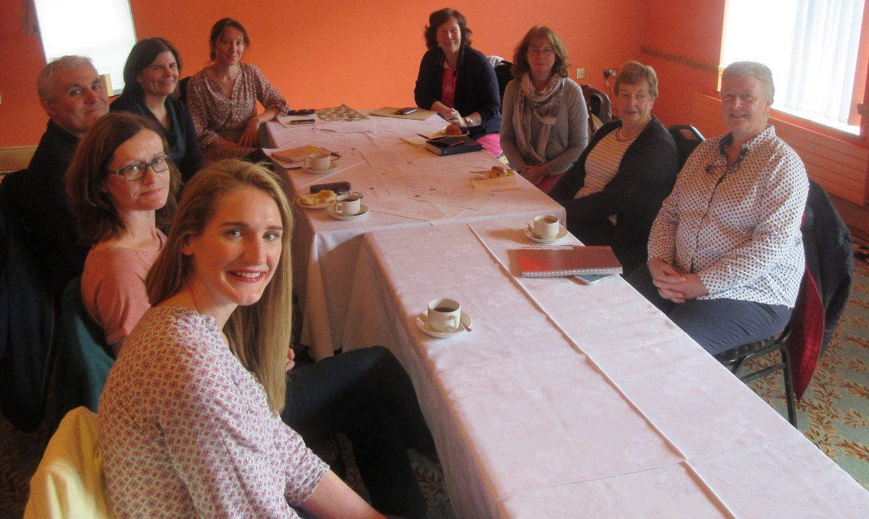
CPTN Members Meeting

Chapter 1: Community Participation Training Network - Impact and Effectiveness

This section of the report assesses the achievements and challenges of the Network Development.

Over the life of the project the Community Participation Training Network has held five full Community Participation Training Network meetings, two training taster days and two CPTN workshops.

As previously mentioned the operating context for the Community Participation Training Network has proved to be a very fluid time nationally with changes at a local decision making levels, transferring of decision making power to ‘public’ representative structures, orientated towards increased consultation, inclusion and promoting the voices of those with the lived experiences of exclusion, marginalisation and isolation. There is also the sense that those experiencing marginalisation must work side by side in raising their collective issues.
In the midst of this “challenging policy environment” and the “frustrations” presented by the changes to community development funding streams such as the introduction of Social Inclusion Community Action Programme (SICAP) the Community Participation Training Network was rolled out. Network members felt that much was achieved by providing the opportunity to come together in the first place thereby addressing some of the isolation (such as distance from information, support, expertise and analysis) that some organisations are experiencing and which previously had not been achieved to any great extent in the disability sector.
Against this backdrop of change the Community Participation Training Network developed an innovative programme of action that matched the sector’s own needs and the criteria set down by the funders by:
- Building on the commonalities that exist across the organisations, namely the need to promote needs, issues of people with disabilities and their solutions alongside and equal to their colleagues who support the social inclusion agenda at local government structures,
- Raising awareness of the achievements of the Community Participation Training Network and reflecting its uniqueness in particular that members are all driven by bottom up needs and experiences, and
- Addressing the change in local government policy and practice which was as one members stated was “landed” on the organisations causing stress, worry and “confusion” among organisations and their communities.

Community Participation Training Network Members Feedback

Looking back over the life of the project the Network members agreed that this challenging context gave the Network a raison d’etre to develop “structures to build the connections with each other”, as one organisation reflected:

“The time you spend with other organisations at Network meetings is very different from the time you spend with them at other meetings, we got to know each other better and trust each other more”.

It is this factor of having an opportunity to come together as a group in a structured manner that has contributed most to the development of the Network. Members felt that the Networks development allowed organisations to:

- Share information - “Share learning about other projects…”
- Provide problem solving support - “what I do in this situation approach…”
- Develop an entity that “goes beyond living in the imagination” into a structure that is real “and simple yet provides that opportunity for high level input and discussion”.

Through this mutual learning process members felt a sense that “you are not on your own”. In addition the Network has developed in such a way as to “allow you to speak your mind” thereby developing its own style of facilitation.

Network members agree that “things are better this way” for two of reasons, including:

Increased collective action and connectivity:
“We pulled together…it is different…regular meetings helped”/ “Building communication … more confidence and trust in each other“(Network member).

Provides an avenue to discuss issues that are pertinent the community and voluntary sector as a whole:
“Have somewhere to go (with issues) now …(the Network) established a conduit for giving and receiving information about the local government structures certainly but also about other things like the upcoming election and how to approach it as an organisation” (Network member).

“It allows for discussion and analysis of what is happening (out there in the broader environment” and that helped - programmes like SICAP for instance are becoming an output driven programme …layers and more layers. It is templates driven…it’s good to bring this somewhere” (Network member).

“More focused on the bigger picture now … policy”

“Whole Network is now focused at getting the best representation of our voices… focused on commonalities”

Members agreed that the Community Participation Training Network provided the context and structure to further develop and build on these impacts.

Firstly because it provided relevant training that was “Participant led based on needs identified by participants”, secondly because it was specific – “Nice to have a space that was focused on local government reform – wouldn’t have got it otherwise”, thirdly because it provided the energy to “keep going…wouldn’t have the focus and motivation to keep coming otherwise”.

Members articulated that real change has occurred because of the establishment of the Community Participation Training Network, as it:
- Built confidence regarding the change that is evolving and therefore members feel that they were “better able to face it”.
- Built relationships: “When you meet for a Network meeting you build a different type of relationship with each other”.
- Increased interest in a broader agenda and “brought energy to the sector” that previously was more disparate.
- Provided an opportunity that to come together that organisations would not have either the resources or capacity to develop on their own: “Couldn’t (the organisation) have afforded to do it otherwise”.

Therefore the evaluation have found that members of the Network reflect a very different picture to the one at the end of 2014 with members stating that the Network, outcomes arising from the establishment and development of the Community Participation Training Network, include:
- Diminishes isolation: “I would be very isolated only for the network”/ “I’m more in touch with other organisations at a regional level now”.

Disseminates ideas and information: “It’s great to share ideas on similar issues”.

Provides learning opportunities: “You always learn something from sharing”

Provides support and expertise: “We support each other through the development of the local government structures in our areas”.

Benefits the whole organisation: “The wider organisation realises the importance of the networking and bench marking against other organisation”.

Furthermore members agreed that they now depend on the Community Participation Training Network as “It’s needed more than ever now”/”I never come away frustrated”.

Network members feedback concluded that the Community Participation Training Network after an eighteen month gestation has emerged from bringing a number of disconnected organisations to a group that is clearly ‘a Network’ , reaching the targets originally set out in the application as well as additional unanticipated benefits, including :
- It has built organisational learning by energising organisational staff and volunteers through the training programme and network meetings. It has become a “contact space to explore opportunities, ideas generation…” (Network Member).
- It has established a support structure for organisations and their members to engage with policy development bodies at a local level and to encourage their representation and input to decisions.
- It created a space for the development of Network wherein informal learning and critical awareness can occur.
- It established a communication linkage amongst the members involved in community action at local, regional and national levels for the purposes of support, advice, and strengthens solidarity and partnership resulting in the potential for a united approach and responses to occur to policy development.
- Enhanced communication/sharing of experience of new local government structures and its presence allows “for support in interfacing with policy/decision making structures at a local level” (Network Member)
- Supported and driven by DFI whose vision was “ahead of its time in building an innovative models with a focus on building capacity and confidence in representation of collective social inclusion issues at a local level”(Network Member).

The Community Participation Training Network provided a structure to address the need for ongoing training, advice and guidance in respect to representation of issues, capacity building and motivational development among people with disabilities and their organisations to interface with local government structures.

Network members provided support to one another and shares learning and information. The interviewees indicated in their feedback that the training programme was very relevant as it focused on the new local government reform structures. It allowed participants to “get and develop ideas “collectively which heretofore had not been a priority within the region. One participant summarised the effectiveness of Network development by stating:

“It helped me to think hard about a few key things which we do and do very well and why? It’s what makes this network unique I suppose”.
The participation of organisations and having the opportunity to meet and exchange knowledge, opinion and expertise was a key factor in the success of the Network development. The timing and the relevance of the Network development was another major factor in the success to date.
A key outcome of the Network is that it encouraged “a uniformity within the region” and “increased confidence in pooling information and ideas”. This is a significant outcome not just for the training but also for the Network as a whole as this new found trust is a relatively new development within the region. Participation in training and the Network meetings contributed to breaking down this “distrust” and “sense of not knowing the others”.

Summary

All the Community Participation Training Network members interviewed during the evaluation claimed that involvement in the Network had resulted in very real and positive effects for participant’s representation work and growth in confidence in their skills, energy, motivation and initiated a collective learning process. The project’s records and consultation with the participants shows that the programme was perceived as enjoyable, effective and worthwhile but that this stimulated requests for more training, which the wider Network must now address
by creating opportunities for groups to meet with each other to share experiences and ideas, as well as participate in training and development.
The role of the members in the development of the Community Development Training Network must not be underestimated. Their role as drivers of the ‘project’ was of key importance to the quality and effectiveness of Community Participation Training Network. It was their role in identifying and representing community needs and issues which is of fundamental importance to the delivery of the Community Participation Training Network actions.

The transparent and supportive nature of the Community Participation Training Network combined with a sense that the Disability Federation of Ireland at lead partner would follow through on its actions was a key reason for its’ success. Also, one is struck through observation and through comments from Network members on the degree of openness to new ideas, reciprocity, and trust displayed by the members of the Network. As a network of community organisations, they together displayed a range of leadership qualities which might be seen as the ‘glue’ that holds the Community Participation Network together.
Overall, the Community Participation Training Network exhibited a unique ability to galvanise, stimulate, energise and motivate each other and others to action. They collectively display:

- Collective vision.
- Credibility.
- Belief in the capability of the community to act.
- Ability to communicate.
- Ability to motivate.
- Energy to initiate and sustain action.
- Openness to learning,
- Ability to identify and connect with other related activities.

The Community Participation Training Network sought to increase public consciousness (locally and beyond) of exclusion and possible solutions, to help break down stereotypes of the excluded, and to promote values associated with inclusion through the development of social interaction, interconnection and contact

From its inception, the Community Participation Training Network incorporated consultation as part of its modus operandi. The Network was fundamentally rooted in the concept of consultation, involvement and dialogue with each other.

Furthermore, it embraced the defining concepts that had characterised a community development approach from the beginning, including a bottom up approach to the design of training interventions and a focus on the various dimensions of exclusion and equality.

Chapter 2: Community Participation Training Network (Training Activities) - Impact and Effectiveness

This chapter focuses on the training activities which were identified, developed and delivered by the Community Participation Training Network and which took place over the life of the Training Links Grants Funding Programme 2014 - 2016.

Training Needs Identification

A cornerstone of the Training Links Grants Programme from the point of view of the funders’ documentation and from the Community Participation Training Network’s key rationale for applying to the fund in the first place was that the training was driven by the needs of the individuals and organisations involved. To this end, the Community Participation Training Network members through discussion at Network meetings identified options and agreed on a core set of training programmes that were seen as priority training to address the deficit that exists in respect to the ’new’ local government structures.
This ‘whole network’ approach through discussion and agreement of the training was of significant importance as it allows the training budget to be administered more effectively but also ensured that the effects of the Training Links Grants Programme funding was felt at different levels within individual member organisations. The training ‘plan’ was driven by collective and common needs across the member organisations and as a result this ‘bottom up’ approach ensures that “practical, useful training took place that met my needs and the organisation’s needs” (Participant).

Training Activity

Over 2015 and early 2016 the Community Participation Training Network undertook training activities that “empowers individuals so that they can participate fully in the lives of their communities or as representatives for their local groups / organisations” (Network member)

Training was made available to people with disabilities, family members as well as service staff. The training comprised accredited and non-accredited advocacy training.

Participants were able to ‘pick and choose’ training from a menu of options most suitable for their needs or take part in the whole “package of advocacy training” (Network member). The programmes on offer sought to develop “an enhanced understanding and appreciation of the use of advocacy as well as provide participants with the knowledge and attitudes necessary to develop effective advocacy skills”.

Table 1 below summaries the Community Participation Training programme delivered in 2015/early 2016, including Practical Self Advocacy, Community Development Practice, Governance Training, Health and Wellness, Empowerment and Advocacy and Empowering parents.

Three training programme were not within the remit of the evaluation due to delivery times these included Special Purpose Level 6 Award - Training and Development, Voter Education and Practical Self Advocacy – Course Content delivered to Trainers.

Table 1: Summary of Community Participation Training Programme 2015 and 2016
Training | Location/  Number | Timeframe | Aim
Practical Self Advocacy  (Non accredited) | Galway and Limerick  18 participants | Six Full days over six weeks  June /July 2015, September/October 2015 | To provide participants with the skills, knowledge and attitudes necessary to develop independent, effective self and group advocacy.
Community Development Practice  QQI Level 5 | Galway  5 participants | Three half days over two months September /October 2015 | To equip participants with the knowledge, understanding and ability to engage with PPNs and other representative structures at local level.
Empowerment and Advocacy  QQI Level 6 | Galway  6 participants | Two days  November 2015 | To enhance understanding and appreciation of the use of advocacy and the methodology of empowerment for people with advocacy needs.
Governance Training (Non accredited) | Galway  - participants | Two days  October 2015 | To provide training was to build the capacity of the Network to manage their limited companies more effectively and in accordance with best practice guidelines through the direct payments model.
Health and Wellness (Non accredited) | Galway and Limerick City and Limerick County  22 participants | Three Programmes of 3 half days over three weeks September, October, November 2015 and April 2016 | To support people living with a long term condition who want to maintain an independent, health and an active life.
DESSA Empowering Parents of Children with Disabilities under 12 and Adults  (Non accredited) | Galway  31 participants | Two programmes of  Six weeks  February /March 2016  6 half days | To encourage parents to think differently about their child’s disability, to see new possibilities and adopt new approaches. It also aims to enable parents to get the most form public services and access supports within their local community, by building confidence and advocacy skills.
Community Participation Training Network Training Programmes Participant Feedback
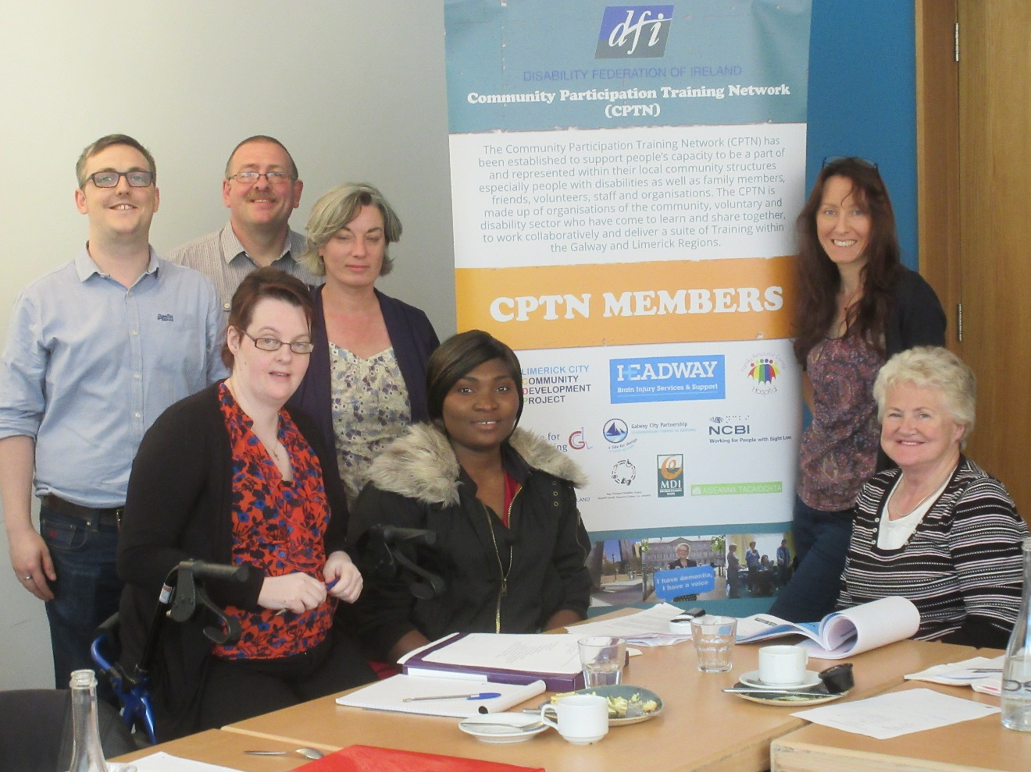
Community Development Practice Training – Galway
Key to measuring the impact of any training programme is participants feedback and own analysis of their learning. The following section gives a sense of the positive outcomes garnered by participants who took part in the Community Participation Training Network menu of training programme.

Accredited Training:

Community Development QQI Level 5 and Empowerment and Advocacy QQI Level 6

Both training programmes were accredited by the Open College Network. Each of the sample of participants who participated in the evaluation process indicated that the programmes “were excellent” and strongly agreed that it further developed their knowledge and understanding of in the area of community development, empowerment and advocacy.

Factors contributing to the success of the programme included:
- Tutors: The “tutor’s hands on experience and knowledge” enhanced learning and development.
- Group Learning and Networking: “The learning and networking within the group and looking at how different organisations used advocacy and empowerment” was deemed in each case as particularly useful.
- The application of learning was also to the fore front of participants learning: “To be able to put into practice with the people that I support”.
- Practical aspects to the programmes delivery were also highlighted: “It was great that the modules were printed up”.

Non Accredited Training:

Practical Self Advocacy
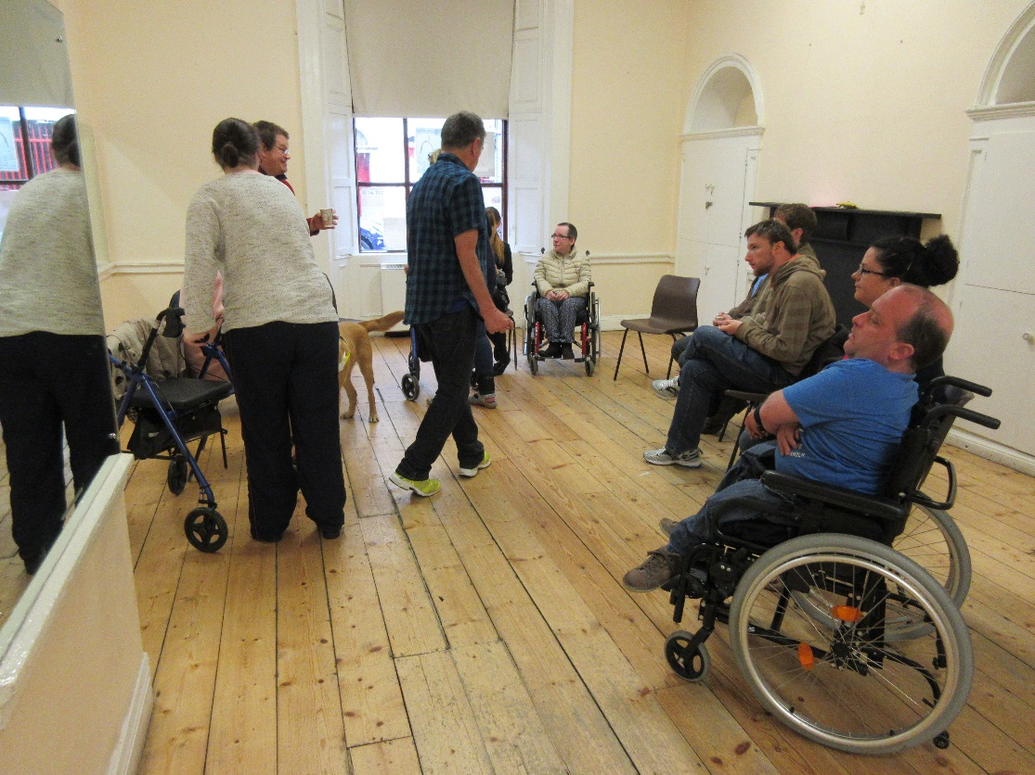
Practical Self Advocacy Training – Galway
For all participants in the evaluation process who took part in the Self Advocacy programme the feedback was overwhelmingly positive. When asked what the participants liked most about the training they reflected consistently “Informal/participatory way of learning, it was a fun group”.
Factors contributing to the success of the programme include:
- Tutor: “He opened lots of windows of wonder to us all…such a great way of delivering…his approach has stayed with me”
- Group Learning and Networking: “I got a lot from hearing people with disabilities talk about their struggles and what advocacy meant to them”/”I enjoyed meeting new and different people”.
- Personal outcomes and Impact: “Opportunity to self-develop as an individual and gain confidence and follow my dreams (with a five year plan”/“Inspiring to see others growing through the course. I realised how difficult and important advocacy can be in my life, that I have a right to say what I think and feel and need, even if I don’t get it”.

However, there were some suggestions raised in respect to the programme that would enhance any future delivery in respect to advocating and acting as an inclusion representative on local government structures such as when asked ‘Do you feel connected and in a position to influence the working/ outcomes of the new local government structures?’ The majority of evaluation participants indicated that they were not and that participation in the programme would not make them feel any more connected.

Some participants articulated that “I’m not at that stage for me it was more personal self-advocacy” and “No, but that is my choice, I don’t have a great interest in local politics. Perhaps course could have linked more to options for getting involved”.

When asked ‘Do you feel that you now have the skills you need to participate?’ there was a sense from the majority of participants (with the exception of one) that “Perhaps but it would be a big leap and commitment, would need more info. on the structures and the issues that might be worked on”.

Again when asked ‘What do you consider to be required if you are to participate in local government structures?’ participants were in agreement that more focused training and support specifically in interfacing with the structures themselves was required:
“Probably a review of advocacy linked to a workshop on the new structures and what difference advocacy might make to our lives. Quite demotivated about politics and possibility of making any change”.

DESSA Empowering Parents: Support to and Provision of Capacity Building Activities
The Empowering Parents Programme was especially active in introducing a wide range of families in a supported environment to advocacy on behalf of their children and themselves and contributing to community activism, decision making and change. These actions set out to ensure opportunities were taken up, utilised and eventually lead to autonomous groups representing families. Participants own learning was immense with the learning cornerstone being “you can’t challenge the system if you don’t know it”. Therefore the programme were adapted to “meet the information needs of parents” by exploring the different models of disability, legislation and policy with particular reference to accessing education supports for their children, New Directions, Person Centred Planning, Direct Payments and Decongregation and all in a context of “learning how to apply specific advocacy approaches to individual situations”.

Like the other training programmes delivered by the Community Participation Network participants indicated that the main benefit was:
“meeting other people with similar issues – strengthen the alliance and hare experiences”
”coming together as a group, sharing experiences, learning how to access information and use it”.
Key outcomes arising from the group included development and delivery of policy submissions on issues identified by parents in relation to:
- Day services submitted to the New Directions National Implementation Working Group,
- The Reconfiguration of Services submitted to the Health Board Executive West.

Perhaps the most impressive outcome and legacy of the training was the continuation of the groups (and expansion) of one of the groups:

“who have since broadened their membership, made contact with Inclusion Ireland as an ongoing support resource and are planning a strategic planning activity to bring clarity to the group which will be facilitated internally by a planning sub group”.
(Source: DESSA Empowering Parents Report to Community Participation Training Network April 2016).

Similarly, the second group identified further steps in development including staying in touch with one another and establishing a peer support group as well as accessing a sibling support service for their non-disabled children.

Health and Wellness Programme

A particular innovative feature of the training programmes was the ‘thinking outside the box’ approach. The ‘Health and Well-ness’ component of the training and Empowering Parents whilst not anticipated initially in the Training Links Grant Application formed a ground breaking feature of the Community Participation Training Network training programme providing a holistic and relevant training programme to the participants involved. Very interesting feedback arose from the evaluation process participants described the programme:

“as magic, it was lovely for everyone…we were very unified not focused on disability it was about motivating a change in behaviour”.

The tutor in particular was cited as instrumental in this approach as she created “a relaxed enjoyable atmosphere”. Participants indicated that she acknowledged “that everyone had their story”.

The tutor herself stated that the message that “life is harder if you don’t help yourself” was core to her approach:

“the focus is to ensure that everyone goes away …making small changes and a can do attitude. Everyone has choices about their diet…their well being, there is real empowerment in that”.

This shift in promoting that self-help approach is a key success factor in the development and outcomes of this particular programme. While this training may seem somewhat ‘off centre’ to the focus of the Community Participation Training Network programme but the justification was clear - people need to look after themselves, be empowered in the management of their own lives in order to participate in the demands of representing the needs of people experiencing exclusion in any form.

Governance Training

The Governance training programme was very much focused preparing organisations for the impact of new legislation including the new Charities Regulatory Authority and the enactment of the new Companies (Consolidations Act 2014). In this context the training programme sought to examine:
- The distinct roles and responsibilities associated with voluntary directorships and the recognition of good governance policies and procedures, and
- Effective communication systems, management meetings and an overview of employment legislation and the required procedures.

The programme sought to build capacity of organisations to operate in a “business model” (tutor). Both employers and employees attended the programme who found it “to be most beneficial…with lots of information provided” (participant).
There was a sense that there was “a need for more time or a longer programme to provide an opportunity for more in-depth discussion as all organisations and employment situation are different” (Participant).

‘Employment issues/cases studies’ garnered a lot of discussion and questions ranging from employment contracts to minimum wage rights particularly in the context of the direct payment model. The tutor did provide some on-going support to participants post training essentially signposting where to go for further information. Whilst the programme was especially relevant strategically to organisations it would appear that it also raised the gaps that exist in respect to implementation of legislation and “the need to know where to go for (definitive) info on individual cases of employment and contract” (participant).

Outcomes – Ethos and Approach

On review of the training components of the Community Participation Training Network it was apparent that the following methods were central to its ethos:

Outreach – The Community Participation Training Network built personal contacts and relationships between organisations within the network. This is a key strength of the Community Participation Training. In respect to the training the Network displayed a willingness to reach out to isolated individuals and communities that is now embedded in the Network’s day to day operation.

Responsiveness – The Community Participation Training Network consulted and negotiated programmes/events with individuals/groups and adapted to individuals/groups changing interests and needs. For instance, the delivery of the Health and Wellness training programme operated from the “need for a person to take care of themselves before they can feel fully confident in participating in very demanding decision making structures” (participant). Even at the Network level discussion flowed according to the needs of the members for example in advance of the 2016 General Election the evaluator observed a keen discussion on how best to raise issues with candidates and a collective approach was developed in Limerick and Galway with the support of the Disability Federation of Ireland.

Locally based activities – The tutors were willing to ‘go to groups’ as opposed to groups coming to a centralised site. This facilitated access at a local level. This approach cannot be underestimated for people with disabilities, those living in rural or isolated geographical areas – “I liked that I didn’t have to travel too far to attend” (participant).

Flexible arrangements – Training activities were organised by the Community Participation Training Network to take account of people’s needs e.g. note taking, access etc., and were delivered during hours which suited people.

Informal delivery style – The primary aim for tutors in particular was to create a friendly and supportive environment characterised by respect for the experience and abilities of individuals “I never experienced a tutor like him…he was inspiring in the way he delivered the training”(Participant).

Took people’s experience/inexperience of participation in a network and advocacy, community development training into account - The Community Participation Training Network understood that it takes time to build confidence and trust of people with negative experiences of group and community involvement.

Mixed learning methods – Activities involved a variety of learning methods, including small group work, discussion, role play, presentations etc. Visual and documentary resources were produced -”It opened another world to me… it was a window to wonder really…”

Worked at participants own pace – The tutors delivering training and adapted their methods to suit the pace of the group/individuals “I was conscious that this was new to them so we chatted first and just allowed their own experiences come out and be shared...it was very affirming, they realised they knew more than they thought about diet” (Tutor).

Shared learning based on individuals experience – The content of the Community Participation Training Network programme of training activity was firmly based on participants own experience, perceptions and expectations. The tutors encouraged participants to share skills and learn from each other. The overall approach was participatory and egalitarian.

Outcomes: Impacts and Effectiveness of the Training Programmes

Based on the review and evaluation of the training programme the overall outcomes included:
- Devising a cost effective way of commencing the process of up skilling and building the capacity of volunteers to interface with local government structures,
- Content of the training driven by the needs of the participants,
- Knowledge of trainers of a high calibre, and
- Lessened the potential for duplication of training across the region.

Ninety four participants took part in the Community Participation Training Network training programme (with a further 20 potentially taking part in Train the Trainer and Community Representation). The common aspects of the Community Participation Training Network approach that are particularly appreciated by the participants were:
- The unstinting support for groups and individuals.
- The sharing of information and resources.
- The willingness to take time to discuss activities.
- The informal and relaxed style, and
- The tutors respect for the experiences of individuals and groups.

The impact of the training based on content analysis arising from the sample interviews with Network members and participants suggest that the training programmes were highly effective and garnered direct positive outcomes and impacts for the participants. The programme was seen as “practical and (I) will use the learning in representing the community and moving forward” (participant) and “will make me able to articulate my work better” and “gave me greater validation about the work I do (participant)”.

The outcomes arising from the training process undertaken by the Community Participation Training Network includes:
- Potential to address absence of role models at a local level: Representatives and potential have emerged to take part in local government structures and other representative structures. While this is limited in number at present the Community Participation Training Network have begun to lay the ground work for the increase in voices for inclusion to emerge.
- Personal confidence and self-esteem has increased: “One of our participants is now looking at a master’s programme…two or three years ago this was not something she felt that she could do” (Network member).
- Seeking to address the barriers that exist to participation in representative roles by providing support:

“People are absorbed in their own lives getting through the day to day tasks is considerable when you have a disability and then they are asked to go to a meeting in the evening…they have to look at support, transport, being prepared, being supported by others at that meeting and having the confidence to voice their needs and the needs of their community…with the new structures this isn’t just people with disabilities (which is considerable in itself) but the voices of all those experiencing social exclusion…it’s a difficult ask” (Network Member)
- Embedded in support at a community level: For many mainstream training programmes there is rarely a support system to provide on-going support, advice and guidance to a person in a representative role at a local level (and beyond). A particularly unique aspect of the Community Participation Training Network training programme and the (network development itself) was those who are representing issue at the local government level in PPNs have a support mechanism established. For example, the Step Forward Disability Group provides support to its representatives in their representative activities at a Network and local government structure levels.
“I have somewhere to go with the information and knowledge, I can bring it back to the group and discuss it …this allows me to distil the information and break it down into manageable pieces. Also while I’m learning the others are too” (Participant).

- Provided a more ‘inclusive’ picture of what marginalisation, discrimination and inequality: The training programme provided an introduction to the broader ‘inclusion agenda’ by setting it in the context of the Network development but also introducing it to participants in each element of the training programme.
“I see how the disability voice has to be raised but the training has helped me see that I will as a social inclusion rep that I have to understand and voice the needs of others too” (Participant).

In conclusion, participants whom otherwise had limited access to learning opportunities gained a new depth of knowledge that empowered them to become more focused, more confident, and more effective in setting, achieving goals and measuring outcomes for themselves, their organisations and for their communities in current and potential representative roles.

Summary

The Community Participation Training Network training programme was valuable from the point of view of the organisations involved in the Network itself and the participants for the following reasons:
- It succeeded in improving training access for participants who are acting or potentially may act in the future as representatives in local government reform structures who required up skilling in a supportive context.
- It responded to a proven demand.
- It provided an overall model of good practice in training development.

In addition this training programme provides a valuable support and development context for Network members in the Galway/Limerick region as the training programme provided a structure to the Network’s development.
The project offered a menu of training options to a range of people who have experience and those with limited experience of participating of local government structures and strove to be effective in attracting the participation of those who have experienced marginalisation, or feel excluded from mainstream training activities.

Through the local, developmental and accessible nature of the training activities, those who may otherwise have had little involvement in the decision making of their community were encouraged to engage in training. As a result, for many of the participants it became a living, vibrant and meaningful part of their everyday life, as one participant summarised it:

“I enjoyed every minute of my participation in the advocacy Course. He guided and encouraged the group to have confidence in our own ability“.

There were some clear signposts for the further development of the training arising from participants and Network members that have to ability to focus a strategic approach going forward. These include:
- Governance training should be longer and requires a post training support mechanisms especially in respect to employer legislation.
- A training programme focused solely on Local Government Structures and other representative structures providing representative skills development should be devised and delivered as a natural progression to the empowerment and advocacy programmes.
- The Health and Wellness Programme should be mainstreamed as part of any forthcoming pre development and development programme.
- At a strategic Community Participation Training Network level the training has consolidated group development in the case of the Step Forward Group and created an empowered parents group and potentially a second. These groups should be seen as a policy and practice resource to draw upon in respect to policy and practice formation.

Chapter 3: The Impact of the Community Participation Training Network for Policy and Practice.

This section provides a brief commentary related to the impact of the Community Participation Training Network as a whole, the impact of particular elements of the ‘project’, and an outline of the strategic learning that has arisen for policy and practice.

Strategic Outcomes – Community Participation Training Network

Arising from the evaluation process the main results of Community Participation Training Network development and delivery include:
- Acted as a means of encouraging dialogue between the member organisations on the relevant problems and challenges posed by exclusion, inequality and discrimination.
- Appreciation of the potential of the Network in changing attitudes and values of the disability sector in coming together as a group rather than adhering to strictly defined territory, issues and themes -“the reform of the local government structures have propelled us into working together where before this we would pretty much do our own thing…so that at least is something good coming from this change” (Network member).
- Awareness of the power of “feeling supported by each other” and facilitating confidence and equality among individuals and organisation involved in the Community Participation Training Network.
- Increased awareness and analysis of the cultural, social and economic factors that influence local communities and exclusion beyond the disability remit “great to have other organisations involved that are not solely focused on disability…this is really fairly new for us”, and
- Identification of a shared vision.

These outcomes essentially reflect the desired outcomes of community development – participation, equality, inclusiveness, development, communication, collective activities and identification of a shared vision.

The Community Participation Training Network participants identified a growth in pride in the themselves - this was particularly evidenced amongst the focus group participants - where they articulated that heightened levels of assertiveness, self-esteem and increased self-confidence after participants have become involved in group training activities. The result of these changes manifested themselves in people trying new things, running and organizing events/groups for themselves, becoming involved in groups or taking steps to create better conditions in their own lives.

All the participants interviewed indicated that they had gained confidence, energy and motivation from being involved and supported by Community Participation Training Network.

However, other achievements and impacts have taken place. One of the main achievements of the ‘Project’ has been the development of a learning matrix of innovative actions and practices that is based on the proximity of the Community Participation Training Network strategic partners to the circumstances and needs of the participants experiencing exclusion and informed by a commitment to finding solutions that work.

An important measure of the effectiveness of an approach is participant satisfaction. In this respect there is no question but that the Community Participation Training Network has succeeded in responding fully to the needs and expectations of its participants. One of the most striking impressions gained from participant feedback was the degree of harmony amongst participants in regard to their positive perception of their learning experiences, their overwhelming enthusiasm for it and the high regard in which the tutors and the Disability Federation of Ireland staff member who took on co-ordination of the ‘project’ was held.

The Community Participation Training Network was built on the seeking of inclusion, and the fostering of a climate of equality and solidarity previously less obvious in the disability sector. It believed in the idea that people have much to contribute to their community. It also builds on the idea that people should have a say in decisions made by government and local authorities about their lives. Above all the Community Participation Training Network was built upon the ethos of finding a new and accessible way for people to participate in the life of their community and the decision making structure that can be available to them.

This was achieved through the encouragement of individual, group development and autonomy. The Step Forward Group in Limerick was already established prior to the development of the Community Development Training Network but “group connections were further enhanced due to the participation in the training” consolidating the group even further. One new group (and potentially a second) has been formed arising from the DESSA Empowering Parents training. This has resulted in greater participation in self-advocacy, community action and activity now and into the future. Overall the evidence is that the Community Participation Training Network has contributed significantly to group development through imparting skills, information and resources to help groups self-organise. It is reasonable to surmise that these groups would not have developed and survived without the contribution of the Community Participation Training Network.

The bonds that build a network are as much about shared experience, as about the operating environment and services. The Community Participation Training Network assisting individuals and groups identify and express issues and needs and commence the process of building capacity to represent these needs for themselves at local, regional and national levels.

Policy Outcomes – Community Participation Training Network

The development of one voice on issues of crucial importance to the local community is an important principle of community development. The key outcomes of the Community Participation Training Network is the development of innovative responses to exclusion and a body of practice and policy lessons that has the potential to inform and influence further action.

It could be argued that the main impact of the Community Participation Training Network has been that it succeeded in raising awareness and consciousness about issues related to exclusion in general as demonstrated through the training outcomes. Tangible outputs have begun to emerge from the Empowering Parents Groups with policy submissions developed and presented to the New Directions National Implementation Group and to Health Service Executive West Early Intervention Group.

Operational Outcomes – Community Participation Training Network

All Community Participation Training Network members interviewed felt that the Network activities and training had resulted in very positive changes in the lives and general state of mind of participants. However, it is important to stress that concrete outcomes such as job acquisition or enrolment in formal education, though desirable, should not be considered as standards by which to judge participants progress. While these outcomes are firmly set down in the context of the Training Links Grants Programme 2014 - 2016 that nature of the ‘project’ what that of a more pre development process for the majority of participants introducing them to self- advocacy in an innovative and a reflective manner.

Dissemination of the information in respect to outcomes and achievement of the Community Participation Training Network has been relatively low key. However, the Disability Federation of Ireland has introduced the development of similar Network structures in Dublin and County Mayo. Both initiatives have been very much driven by the Disability Federation of Ireland staff members co-ordinating the ‘project’. Interest in the roll out of similar networks in these areas has been positive and it is anticipated that this will be further consolidated when the future strategic development of the Community Participation Training Network is developed post Training Links Funding.

The Community Participation Training Network itself has resulted is a dynamic group that has the potential to expand and grow beyond the deliverance of training measures. It has resulted in tangible outcomes including the enhanced ability of disability and other broader inclusion focused organisations to come together in setting and realizing common goals.

None of this would have developed at this time without the support of the Training Links Grants Programme funding.

Chapter 4: Future Planning and Development of Community Participation Training Network

This section of the evaluation considers some of the challenges that identified by stakeholders during the evaluation process and options for future developments based on the opinions of members of the Community Participation Training Network.

Challenges to Further Community Participation Training Network Development

The challenge for the Community Participation Training Network is how best to move forward with the ending of the Training Links Grant Programme funding. Moreover given the financial constraints of the Network, there needs to be some consideration of funding options for the future.

In addition whilst the Network is moving towards completion of its aims and objectives further cognisance of the placement and ongoing support of representatives and support mechanism is required.

There is no question that the Community Participation Training Network provides a hub for analysis of issues pertaining to representation and a mechanism of support:
“The Network is about capacity building, encourages real participation and opportunity to come together with a real movement by your side however the challenge remains at local government level …inclusion in decision making … but the attitude still remains you can come in if you are able”.
Therefore the Community Participation Training Network must consider outputs that support this process of engagement in local reform structures in the medium and long term particularly amongst representatives already or potentially moving into representative roles at a local authority level.

In addition some Network member’s attendance can be inconsistent (often for reasons of time constraints and priorities within their own organisations). This requires clarity around membership and possibly expanding to include other organisations to enhance the social inclusion platform within the Network.

Some members of the Network have raised the issue of workers representation at the Network meetings as “opposed to our organisation members”. Certainly organisation member’s participation in the Network is something to be viewed as a core objective going forward and which requires discussion at the Network level.

There is no sense of venting and ‘storming’ in the Network which is a legitimate stage of group development. Whilst this has positive aspects the natural cycle of group development can actually benefit from a ‘storming phase’. The questioning and the challenging within a group is a normal group process and the Network may benefit from this reflection through the discussion and development of a long term sustainable strategic plan.

In addition, there is in this strategic planning process a need to identify themes, and develop a position on issues “that you can call upon” that will support the representatives as they move forward into position of influence at a local level.

There has been limited policy development formulation but this would appear to be reasonable considering the timeframe and the efforts in establishing the Network itself. However it is important to remember that community development seeks to identify and define issues of public concern and inform and influence public policy in relation to those issues. Policy development is an important piece of work which the Network must consider going forward and plan to must carry out.

The Community Participation and Training Network has been diligent in the roll out of training and Network development as per it funding agreement but again will have to be conscious of developing a strategic focus and position going forward.

The Community Participation Training Network members indicated that an essential aspect of Community Participation Training Network was the development of training programmes to enable people with disabilities to self-advocate and /or advocate with or on behalf of other. While participants are drawn from the disability sector the Community Participation Training Network promoted the opportunity for people with disabilities to become community representatives “within a mainstream context” as the ‘new’ structures demand.

The evaluation evidence suggests that this did not occur in the way it anticipated at the outset of the ‘project’. However it did occur in a different way namely through the Empowering Parents Programme which has the potential eventually (if members so wish) to move into the arena of the local government reform structures. The Step Forward Group has further consolidated its strengths as a support and policy development group. Both are available structures to the Community Participation Training Network that has the potential to be included as members of the Community Participation Training Network and could be drawn upon to input into policy development.

The Community Participation Training Network has assisted in developing a ‘pre development’ environment and capacity building programme for its community. This must be counted as a major achievement. However there is a need to build upon this. A key quality for any development group is an expanded intuition in sensing what to do, when to do it and when to move forward. While there will always be a need for capacity building and pre development work the Community Participation Training Network has reached a place where is must take further steps to improve the process of empowerment and quality of life of the community. The Network must look towards the idea of sustainability, where there is a stable support infrastructure that has a lasting capacity to meet advocates and representatives needs and promote community wellbeing.

Conclusion

The Community Participation Training Network development saw the implementation of a series of innovative, interactive and wide ranging activities all bound together with a focus on inclusion and supporting representatives to self-advocate and advocate with and on behalf of others. A concentrated and focused set of activities were attentive to many target groups – children, young people, families, women, men and rural communities – involving so many stakeholders and using so many different methods.
The ambitious nature of the Community Participation Network and its various activities has been matched by great professionalism, positive results and great learning for the future. It continues in its commitment to combatting exclusion and discrimination. However, it must seek the recognition it deserves as well as be supported in its work by policy makers through increased resources.

The Community Participation Training Network was for many in the community the only window of opportunity available to them in raising issues of exclusion; it would be a failure on behalf of policy makers if its work was diminished due to lack of recognition, funding or support.

In order to ensure Network sustainability the following recommendations arise from both the Network members and the evaluator. It is anticipated that once the evaluation process is complete that these recommendations will be achieved or included in the Community Participation Training Network Strategic Plan.

Recommendation 1: Development of a Strategic Plan
A Strategic Plan should be developed on foot of the evaluation completion, which is fully costed and agreed by all members of the Network. The planning process needs to be reflected upon with the Network members taking some responsibility for aspects of the delivery of future strategic plan such as policy development and research. A less ambition plan of action with a clear division of labour should be developed in order to prevent member ‘burn out’ and a dilution of the Network’s impact – a process of small steps is advised to ensure targeted, planned, shared and strategic outcomes are achieved over the next three years..

Recommendation 2: Development of a Funding Strategy
Funding options should be explored in advance of the ending of the Training Links Grants Programme, possibly with support from Local Authorities in each of the Community Participation Training Network area of operation. Other possible funding sources should be explored including private company sources and Education and Training Boards.

Recommendation 3: Inclusion of Representatives and On Going Support
Development of a sustainable and relevant support output for representatives should be developed on foot of training programme this should include focus training representation of issues at local, regional and national levels, a ‘handbook’ developed to provide guidance and support, enhancement of group develop to support the ‘representative’ in his or her action based on the model already developed by the Step Forward group. Achieving inclusion is an active process of people participation. It is not something that can be done to people but must be done with and by them. One important step towards is to seek to include persons experiencing exclusion for participation as members of the Network itself such as members of the existing Network organisations and active inclusion of the Empowering Parents Group.

Recommendation 4: Communication of Network Achievements
The positives outcomes and innovation arising from the Community Participation Training Network should be communicated in local operating areas through local media, presentations and discussions.

Recommendation 5: Network Review of Terms of Reference
The Network members should review their terms of reference to ascertain what change may need to occur post development of a strategic plan.

Recommendation 6: Policy Development
A Community Participation Training Network Policy Sub Group should be established to identify one key policy issue per year and plan for research, discussion, consultation and dissemination through seminar and special newsletter etc. to support representation at local, regional and national levels. At a strategic Community Participation Training Network level the training has consolidated group development in the case of the Step Forward Group and created an empowered parents group and potentially a second. These groups should be seen as a policy and practice resource to draw upon in respect to policy and practice formation.

Recommendation 7: Training Development
Future training programmes should be focused on Local Government Structures and other representative structures providing representative skills development as a natural progression to the empowerment and advocacy programmes. Legislation changes in governance and employment should be considered in any forthcoming Community Participation Training Network Strategic Plan. Pre development training should take on board the learning arising from the innovative development of such training programmes as the Health and Wellness Programme and DESSA Empowering Parents.

References

Department of the Environment, Community and Local Government (2012). Putting People First Action Programme for Effective Local Government. Dublin. Government of Ireland

Department of Health and Children (2012). Value for Money and Policy Review of Disability Services in Ireland. Dublin. Government of Ireland.

Disability Federation of Ireland (2014). Application to Training Links Grants Programme 2014 – 2016.

The Wheel (2009). Training Links Steering Committee Terms of Reference.

Appendix 1: Summary of the Process of Establishment of PPN Structures
In order to establish the PPNs the roll generally comprised the following in each local authority area.
- All community and voluntary groups were asked to register with the PPN irrespective of previous affiliation to the Community and Voluntary Forum.
- All groups shall indicate which Municipal District they are affiliated to.
- All groups shall indicate whether they are Social Inclusion, Environmental or voluntary based. These groupings are defined as follows:
Social Inclusion – An organisation’s primary objectives and activities must focus on social inclusion/social justice/equality.
Environmental – An organisations primary objectives and activities must be environmental (i.e. ecological) protection and/or environmental sustainability. Membership of this college is validated by the Environmental Pillar at a national level.
Voluntary – Organisations whose primary objectives are other than those listed above become members of the Voluntary grouping.
The above then determine the various electoral colleges within the PPN.
It should also be noted that a group is considered as more than one person and a body that has an agreed set of rules and a working structure that informs the appropriate workings and structures for that organization.
The PPN committees operate from Municipal District to County level with an elected Secretariat overseeing the full process. The roles are outlined below:
Municipal District PPN -2 Meetings per annum
Its role is to:
1. To network community groups.
2. To establish objectives to promote the well being of this and future generations.
3. To make recommendations to the Secretariat who will action these issues.
4. To elect one members to the Secretariat,
5. Each organisation has one vote and but may send two representatives made up from all Social Inclusion, Environmental and Voluntary groups in the Municipal District.
County PPN – 2 meetings per year
Its role is to:
1. Main Channel for selecting representatives for boards and committees.
2. Main Channel for selecting pillar representatives made up from all Social Inclusion Environmental and Voluntary groups in the County.
Secretariat – 5 meetings per year
Its role is to:
1. Facilitate implementation of decisions but is not a decision making structure.
2. Ensure PPN functions between plenary meetings.
3. Coordinate PPN activities.
4. Communicate with PPN members made up from 15 representatives selected by the Community, Social Inclusion and Voluntary groups selected at the County PPN and three representatives selected by the Municipal District.
Linkage Groups
Linkage Groups are decision making groups and as mechanism is central to ensuring that all member organisations are enabled to participate in shaping the decisions that affect them that are being developed by any structure of the Local Authority. Linkage groups deal with specific issues. Each representative taking up a position on a linkage group must represent the views of their linkage group and not just those of their own organisations.
Local Community Development Committee (LCDC)
A Local Community Development Committee (LCDC) is established in each Local Authority area as a committee of the Local Authority under the Local Government Act 2014. The LCDC is independent of the Local Authority in the discharge of its functions. The LCDC is made up of 15 – 17 members with a minimum of two persons representing social inclusion interests, a minimum of two person representing community and voluntary interests and a minimum of one person representing environmental interests, a maximum of three person representing local development or community development bodies, in the respective administrative area. The Local Economic and Community Plan is a six year plan and it is prepared by the Local Community Development Committee. It has two elements a local economic element prepared by the local Authority and a community development element prepared by the Local Community Development Committee (LCDC). The plan is the guide for the economic, social and cultural development of the administrative area.

Disability Federation of Ireland (2014) Application to Training Links Grants Programme 2014 – 2016
The Wheel is a support and representative body connecting community and voluntary and charities across Ireland. www.wheel.ie
The Wheel: Sector Skills Programme: Executive Overview
The Wheel. Training Links Steering Committee Terms of Reference. January 2009.
Training Links Grant Application 2014 – 2016 Disability Federation of Ireland
Disability Federation of Ireland (2014) Application to Training Links Grants Programme 2014 – 2016
Disability Federation of Ireland: Training Links Grants Programme 2014 – 2016 Application Form
DESSA Report to Community Participation Training Network April 2016
ibid
ibid

