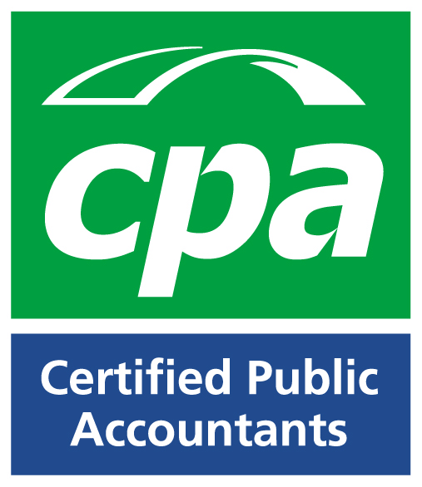
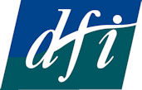
Keeping the books
- Best practice guide to accountancy for charities

A joint initiative with the Institute of Certified Public Accountants (CPA) and the Disability federation of Ireland (DFI)

Key Features of the Charities Bill 2007

The Charities Bill 2007 was published in April 2007 and contains significant legislative changes for the Charity sector. The Institute of Certified Public Accountants in Ireland (CPA) aims to report on the key features of the Bill so that charitable organisations are better prepared for the changes that lie ahead of them.

The key features of the Charities Bill 2007 are as follows:

Definition of Charitable Purpose

The Bill defines charitable purpose as being:
- The prevention or relief of poverty or economic hardship,
- The advancement of education,
- The advancement of religion,
- Any other purpose that is of benefit to the community.

A purpose shall not be regarded as a charitable purpose unless it is of public benefit.

Establishment of Charities Regulatory Authority

The Charities Bill 2007 was presented to the Dáil on 20th April 2007 by the Department of Community, Rural & Gaeltacht Affairs and provides for the establishment of the Charities Regulatory Authority (the “Authority”). In relation to charitable organisations and trusts, the general functions of the Authority shall be to:

- Increase public trust and confidence in the management and administration,
- Promote compliance by charity trustees (including all directors and officers of incorporated and unincorporated organisations) with their duties in the control and management,
- Promote the effective use of property,
- Ensure the accountability to donors and the public,
- Establish and maintain a register,
- Ensure and monitor compliance with the Charities Act.

Registration of Charitable Organisations

The Authority will set up and maintain a public register of charitable organisations and all charitable organisations that intend to operate in Ireland must apply to be registered. Existing charitable organisations must apply within 6 months of the establishment of the Authority. Among other required information, an application by a charitable organisation made to the Authority must:

- Specify the name of the organisation, names of trustees and place where it operates,
- Specify the amount of money raised in respect of 3 years before the application,
- Specify the plans in relation to future funding activities,
- Specify the gross income during the financial year immediately preceding the application,
- Include copies of all financial accounts in respect of the 3 years preceding application,
- Include a copy of the constitution,
- Include the appropriate fee, as determined by the Minister.

As soon as practicable, the Authority will enter the following details for the charitable organisation on the register:
- Name and place of business,
- Address of premises in Ireland,
- Name of Charity Trustees,
- The objects of the charitable organisation, among others.

The register will ensure public confidence and deter fraudsters in this area as it will be available for public viewing. The Authority, after consultation with Garda Síochana, will have power to remove any charitable organisation from the register if it is promoting purposes that are unlawful, immoral, terrorist activities or for the benefit of unlawful organisation. A person that holds out a body that is not registered as being registered is guilty of an offence.

Duty to keep proper books of Account

The Trustees of a charitable organisation have a duty to ensure that proper books and records are kept that correctly record and explain the transactions of the organisation and enable the financial position of the organisation to be determined. The books of account must be kept in such an order to enable the accounts of the organisation to be readily and properly audited. The books of account of a charitable organisation must be kept on a continuous basis and entries must be made in a timely manner and be consistent from one year to the next. Books of account that a charitable organisation must keep include, all receipts and payments and a record of the assets and liabilities. In essence, books of account must give a true and fair view of the state of affairs of the charitable organisation and its transactions.

The books of accounts, along with the annual statement of accounts, should be kept for a period of 6 years. Failure to keep proper books of account is an offence for trustees and penalties will apply.

Annual Statement of Accounts

The charity trustees must ensure that an annual statement of account is prepared in respect of each financial year, in such a form prescribed by the regulations. The exact form will be determined when the Authority is established. Where the gross income or expenditure of a charitable organisation does not exceed €100,000, trustees may prepare an income and expenditure account and a statement of assets and liabilities of the charitable organisation, in a form that will be decided at a later stage by the Minister. This section does not apply to charitable organisations that are companies.

Annual Audit/Examination of Accounts

If the gross income or expenditure of an unincorporated charitable organisation exceeds €100,000 in the relevant financial year or the two preceding years, the accounts must be audited not later than 9 months after the financial year end by a person qualified to be an auditor.

For charitable organisations that fall below the €100,000 limit, the accounts not later than 9 months after the financial year end, must be examined by an independent person approved by the Authority or can elect to have an audit by a person qualified to be an auditor. This concept of “examination” does not exist in company law so the level of assurance that is needed from an examination is not yet known.

Annual Reports

The charity trustees shall, no longer than 10 months after the financial year, prepare and submit to the Authority an “annual report”, in respect of its activities in that financial year.
The report must contain:
  - a copy of the annual statement of accounts or the income and expenditure account and statement of assets and liabilities,
  - a copy of the auditor’s report or independent’s person’s report, where the charitable organisation needs to be audited or examined,
  - for charitable organisations that are companies, a copy of the accounts prepared in accordance with the Companies Acts and where such accounts have been audited, a copy of the auditor’s report.

Public Access of Annual Reports

The Authority will make all annual reports and documents attached available to the members of the public for such a period as the Authority considers appropriate.

Persons disqualified for being Trustees

The Bill sets out the circumstance where a person will cease to hold the position of a trustee. These include bankruptcy, the company being wound up, conviction of an offence or removal by High Court, among others. The Authority will establish and maintain a register of all disqualified trustees and the Bill makes it an offence to act as a charity trustee while disqualified.

Investigations

The Authority will have powers to carry out investigations into the affairs of a charitable organisation and can call for documents and evidence during an investigation.

Charities Appeals Tribunal

The Bill provides for the establishment of a Charity Appeals Tribunal to hear appeals against decisions or determinations of the Regulatory Authority. It is intended to provide an alternative to the courts system by allowing persons or charitable organisations to bring an appeal in a non-judicial setting.

Disability Federation of Ireland

Disability Federation of Ireland (DFI) represents and supports over 150 voluntary disability organisations and groups of which 72 comprise its National Council, and 30 of which are Associate Members. Allied to this, it works with and supports over 200 organisations and groups around the country that have a significant and growing disability interest, mainly coming from the statutory and voluntary sectors. DFI also supports the broader voluntary and disability sector through its representations of the disability strand with the community and voluntary pillar of the social Partnership process, as a social partner at the National Economics and Social Forum, HSE Co-Ordinating Committees and other forum at regional, national and European level.

Fumbally Court, Fumbally Lane, Dublin 8. Tel: 01-4547978 Fax: 01-4547981 Email: info@disability-federation.ie Web: www.disability-federation.ie

Institute of Certified Public Accountants

The Institute of Certified Public Accountants in Ireland (CPA) is one of the leading professional bodies representing accountants and students in Ireland. CPAs operate in public practice, industry, and financial services as well as in the public sector. As the most popular international designation for professional accountants worldwide, a CPA qualification offers a wide variety of high quality career opportunities to members and students in both Ireland and throughout the world.

Institute of Certified Public Accountants, 17 Harcourt Street, Dublin 2, Tel 01 4251000, Fax 01- 4251001 email: info@cpaireland.ie Web: www.cpaireland.ie

