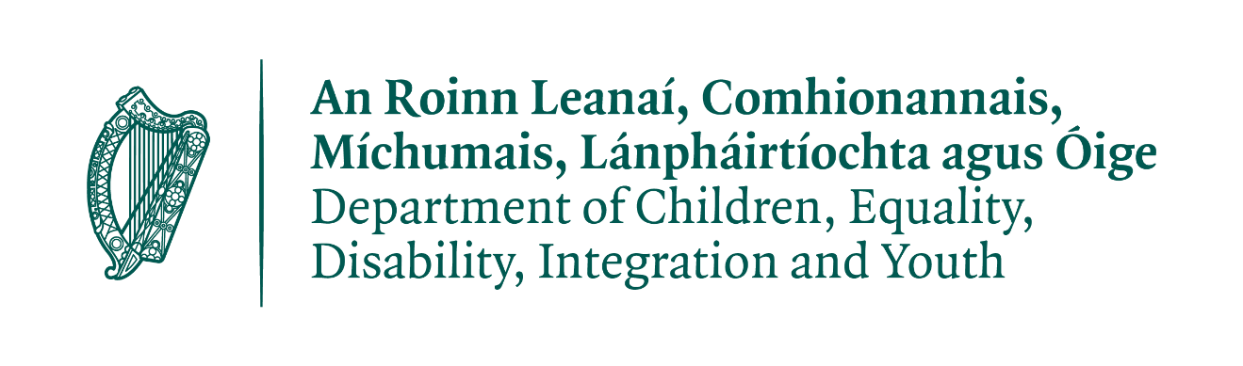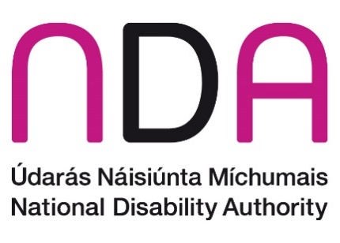

National Disability Strategy call for written submissions

Please answer the questions below and submit to nda-events@nda.ie by Friday 02 February 2024 We ask that you please adhere to the word counts provided. An A4 page with single spaced text font 12 is between 400 and 500 words.
You can also post your submission to:
NDS (National Disability Strategy) Consultation,
National Disability Authority,
25 Clyde Road,
Dublin 4.

About you

Please respond to one of the options below.

I am responding as:
- A representative of another disability organisation
Disability Federation of Ireland (DFI) is a federation of member organisations working with people with disabilities to implement the UN CRPD (Convention on the Rights of Persons with Disabilities) and ensure their equal participation in society. Our vision is an Ireland where people with disabilities are participating fully in all aspects of society. Over 120 disability organisations across Ireland are affiliates or associates of DFI.

Questions
The vision of the United Nations Convention on the Rights of Persons with Disabilities (UNCRPD (United Nations Convention on the Rights of People with Disabilities)), which Ireland has ratified, is that disabled people can exercise their human rights like everyone else in society and have an equal opportunity to live their lives with dignity, respect, and equality.

Question 1: What changes do you see as important to ensure that disabled people in Ireland are fully included in society in line with the vision of the UNCRPD? (Maximum 500 words)

Over the last number of years, there has been a growing imbalance between a primary focus on economic growth over social development cohesion. The NDS offers an important opportunity to correct this, and to deliver for the 1 in 5 people who have a disability/disabling condition, and their families and communities.

A significant range of changes are needed, including:

Health and wellbeing: Disabled people face health inequalities and worse health outcomes than the general population. In Census 2022, over a third of the population with a disability to any extent reported their health status as fair, bad, or very bad - compared to 10% of the general population. In response, the mainstream health service must be disability inclusive and factored into Sláintecare implementation, and the health system restructure e.g. Health Regions.

The transfer of specialist disability services to DCEDIY (Department of Children, Equality, Disability, Integration and Youth) does not negate the Department of Health’s leading role in supporting the overall health and wellbeing of disabled people; with disability considered across all mainstream health services, including public/population health initiatives.
- Disability specialist supports: An aim of disability specialist supports is to enable people to live independently in the community. Access to Personal Assistant and home support services, on an equitable geographical basis, integrated with a range of community-based supports such as employment, peer, information, advocacy and family support, social clubs etc. is essential to this realisation. Personalised budgeting also has potential to support independent living and requires further development and investment.
The Disability Capacity Review and Action Plan outline the investment required to meet demographic change and unmet need. Delivering this requires cross-departmental working and funding. Voluntary disability organisations provide upwards of 70% of specialist services - as a result the NDS should ensure:
- Financial sustainability to ensure continuity of support for disabled people, including recognition of inflationary pressures and rising service costs for community organisations;
- Sufficient funding to recruit and retain staff;
- implementation of the partnership principles of the DoH (Department of Health) Dialogue forum.
- Housing: Carrying forward the theme of independent living, an appropriate, accessible home is a key step to this. However, disabled people have experienced significant housing challenges, long before the current housing crisis. A sufficient supply of universally designed wheelchair liveable housing is required to meet needs in both social housing and the private sector. Local Authorities, Approved Housing Bodies, HSE and voluntary disability organisations working collaboratively can deliver coordinated housing and independent living supports. The Housing Strategy for Disabled People requires resourcing and rigorous implementation.
- Poverty and Cost of Disability: Having sufficient income to meet daily needs and live full lives, free from poverty is fundamental to UN CRPD realisation. People unable to work due to disability have one of the highest poverty and deprivation rates nationally, and Ireland ranks exceptionally low on disability poverty at EU level. Indecon’s Cost of Disability report shows significant additional costs across a range of areas, between €10,379 – €14,673 annually for disabled people (adjusted for 19.3% inflation since 2021 as per CPI). An Action Plan to address this is necessary, with actions from all relevant government departments.
Improving employment for those who wish to work will not in itself be sufficient to address poverty. Indexing social welfare to keep up with inflation and deliver a Minimum Essential Standard of Living, covering the extra Cost of Disability, would ensure that disabled people who cannot work do not live impoverished lives.
- Employment: Ireland performs worst in the EU for disability employment. A range of measures is required as a result, including:
- Targeted employment supports for disabled people and employers.
- Addressing societal attitudes to disability, and
- Ensuring employment protections as employment discrimination persists.
A focus on meaningful employment, not just increasing the employment rate concentrated on low-income jobs, is required. Ensuring too that people have the opportunity and support to access further and higher education and transition seamlessly into employment. Addressing social protection, ancillary benefits and Cost of Disability issues are key here too.
- Community inclusion: Local Authorities have a leading role to play in ensuring inclusive and accessible communities and implementation of UN CRPD, facilitated by:
- Resources to deliver on the UN CRPD.
- Collaboration between local agencies on the ground and mechanisms to ensure the voice of disabled people is heard locally.
- Addressing ongoing deficits in accessible, reliable urban and rural transport.
- Maximising the role and potential of assistive technology, with more coherent investment in this space.

Question 2: What needs to happen for these changes to be achieved? (Maximum 500 words)
Attitudes towards disability must change, in both government and society. In Census 2022 over 1 in 5 people identified as having a disability. Disability is therefore not a niche concern, but a major part of, and priority for, Irish society. At the same time ableism and disparaging attitudes towards disabled people are common, and create barriers to accessing education, employment, housing, and broader inclusion in society. The NDS is an opportunity to address these attitudes and the barriers created as a result.
As a first step, the government must show it is taking disability, and the implementation of the UN CRPD, seriously with its clear prioritisation. Implementation is a complex project that requires effective cross-departmental work and a whole of government approach. The Department of the Taoiseach should take on the defined role outlined for it in the UN CRPD. Article 33 lays out an implementation and monitoring framework - consisting of a focal point, coordination mechanism, and monitoring body. The Government has named the focal point (DCEDIY) and the monitoring body (IHREC (Irish Human Rights and Equality Commission)) but has never named a coordination mechanism. The Department of the Taoiseach should perform this function, to ensure that action across government is coordinated at a senior level and works towards full implementation. Meaningful and effective cross-Departmental work is essential for UN CRPD implementation and has been lacking thus far – each Department has a role to play.
Another crucial step is maintaining the Oireachtas Disability Matters Committee. The Committee has been an important forum in raising the profile on disability issues and working towards accountability and transparency on disability policy in the Oireachtas.
The implementation effort must also be fully resourced. Implementation will require money, staff, and time. Some of these resources already exist and can be redirected and redeployed, as needed over time. Others will have to be increased. Disability services are underfunded and overstretched in many places, as are the mainstream health and community services that many disabled people rely on. These services and supports must be able to meet the needs of their users if the UN CRPD is to be considered fully implemented.
The new NDS needs to be clear, focused, and transparent, with implementation monitored regularly and reported on to the Oireachtas, disability organisations and publicly. The actions of the strategy should therefore be measurable and achievable within its timescale, yet critically they should not lack ambition. The absence of targets was a weakness in the last strategy, making it difficult to measure change over time (NDA (National Disability Authority), 2020 - Mid-term Review of Progress).
Targets require data and adequate data sources to monitor progress, as well as crucially measuring impact and outcomes for individuals. Data collection and management is required under the NDS, in conjunction with the involvement/engagement of disabled people and their representative organisations in a transparent monitoring and implementation process. A stocktake on the required resources, tools, and timelines to achieve the NDS is a prerequisite to implementation.

Question 3: What would a successfully implemented strategy look like? For example, how do you think life should have improved for disabled people in Ireland at the end of a five-year strategy? * (Maximum 500 words)
The NDS is the main mechanism of the State to bring tangible change to people’s lives and to propel implementation of the UN CRPD. With the departmental transfer of functions from DoH to DCEDIY, a cabinet minister with a disability portfolio, legislative developments (e.g. ADM), and publication of several inter-related government action plans and thematic strategies there is an opportunity for progress. The UN CRPD aims to promote, protect, and ensure the full and equal enjoyment of all human rights and fundamental freedoms by all persons with disabilities, and to promote respect for their inherent dignity. This is our aspiration. By the end of the five-year strategy, with targeted and collective actions, we envisage the following positive changes:
- An index-linked income matching the Minimum Essential Standard of Living (above the poverty line), considering, and covering the extra Cost of Disability, lifting, and reducing the risk of poverty for disabled people.
- The Cost of Disability is understood and responded to by all relevant government Departments; evidenced in access to and support regarding housing, health services (including medications and equipment), utilities, assistive technology, access to education, employment, transport etc.
- Those who wish to work are supported to do so, and Ireland’s employment rate at least matches EU averages.
- Improved pathways to independent living, including more accessible, affordable, wheelchair liveable homes are available across private and social providers, and integrated health and social care supports including Personal Assistant provision, are available.
- There is evidence that health outcomes are improving for disabled people and there are targeted programmes within population and public health initiatives.
- Disabled people, DPOs (Disabled Persons Organisations) and their representative organisations are actively involved in the implementation and monitoring of the UN CRPD.
- Budget allocations for disability are understood through greater transparency, and progress can be tracked.
While there are several areas in progress, with existing disability related/relevant strategies and plans across numerous policy areas, government departments continue to act, develop, and implement these plans in a siloed manner. This undermines their effectiveness and leaves those working on disability pulled in many directions. As stated above NDS implementation requires a whole of government approach, strong enforcement, coordination and anchoring within the Department of the Taoiseach.
Successful implementation is also a recognition of the shifting demographics of Irish society. Disabled people are not a homogenous group. Disability intersectionality, discrimination and lack of opportunity can be experienced across several grounds (for example gender, sexuality, race or ethnicity, family status etc) and the narrow lens of disability as a mutually exclusive category of experience is limiting. Ireland must also consider the inter-sectionality between ageing and disability, ensuring policies and services consider this changing demographic and the needs of the increased number of people ageing with a disability or acquiring a disability in older age.
Successful implementation would result in social connectedness and inclusion, underpinned by a human rights approach and partnerships across the disability ecosystem. The NDS is an opportunity to ensure that people have control and agency over their own lives and the direction of their lives; have a home; an adequate income; social connectedness; opportunities equal to others and that barriers to community participation are removed. Recognising that difference at times requires special attention, but the rights of the person are paramount, and any attention should not lead to segregation or further segregation for the individual(s).

Question 4: If you have any other views that are relevant to the new National Disability Strategy, please tell us? (Maximum 300 words)

We welcome the focused attention of DCEDIY in the development of the NDS following delays and are engaging in the consultation process across the different mechanisms of engagement. However, as a federation of member organisations, the brief time for the consultation and lack of upfront articulation of all consultation elements has made it difficult to ensure participation of our members and of disabled people. Members of DFI have raised concerns that there was not sufficient time given to consult meaningfully with the disabled people they work to support. The NDA’s guidelines on consultation to ensure participation of disabled people, published in 2022, outline best practice in this regard.
In addition, the noticeably short word limit in the submission template limits meaningful engagement. The consultation is also taking place while many other relevant consultations are underway, leading to a concern about an ongoing lack of coordination and inter-Departmental working - for example there does not seem to be sufficient coordination with the Department of Social Protection, which is in the process of consulting separately on a significant disability reform proposal via the Green Paper. To ensure trust and accountability in the process and future rollout of the NDS, meaningful engagement and considered consultation is a key factor.
Given the depth and breadth of the issues involved, and of our member’s work and perspectives, in the context of the limited work count for this submission we would point to some of our recent policy submissions, which highlight in more detail various issues that the NDS will need to address. These provide the policy evidence and references for the various issues covered briefly in this submission.
- DFI Submission to International Covenant on Economic, Social and Cultural Rights, January 2024, https://www.disability-federation.ie/publications/submission-to-icescr-january-2024/
- DFI Pre Budget Submission to Department of Social Protection, July 2023, https://www.disability-federation.ie/publications/dfis-pre-budget-submission-2024-to-the-dsp/
- DFI Pre Budget 2024 Submission (Long Version), June 2023, https://www.disability-federation.ie/assets/files/pdf/dfi_pre-budget_submission_2024.pdf
- DFI Submission to Ireland’s National Reform Programme 2023, February 2023, https://www.disability-federation.ie/publications/dfi-submission-to-irelands-national-reform-progra/
- DFI Submission on Disability Action Plan 2022-25, October 2021, https://www.disability-federation.ie/publications/dfi-submission-on-disability-action-plan-202225/

