DFI Annual Plan 2010

Table of Contents

Focus and orientation of 2010 work 3

Work actions related to each objective 7

Strategic Objective 1: Support and Service Provision. 7

Strategic Objective 2: Influencing Policy. 13

Strategic Objective 3: Building a National Platform 19

Strategic Objective 4: Strategic Implementation Framework. 24

Focus and orientation of 2010 work
The DFI Annual Plan 2010 is developed in the context of the Operational Plan 2008 – 2010 and the DFI Strategic Plan 2004 – 2010. The Board and Executive also have the “Review of Implementation of Operational Plan in 2009”, December ’09, prepared by external evaluator Stephen Rourke.

At the start of last year we stated that “DFI needs to simultaneously focus in a number of directions. On the one hand it must ensure that it remains close and relevant to its membership while at the same time it also needs to concentrate on maximising its influence on how Government and the HSE, in particular but not exclusively, make decisions that will affect the lives and services available to disabled people over the next five years”. Also at that time the Board’s view was that the Annual Plan needed “to be implemented firmly within the context of the deteriorating economic outlook”. These strongly remain our position in presenting the 2010 Annual Plan; remaining ‘close and relevant’ to our membership will be more challenging as organisations come under pressure as never before.

The year ahead will be challenging for our member organisations. Our experience last year has led us to understand that we need to be more assertive and directive in relation to providing supports to our members. The recession is decreasing the amount of funding, both statutory and fundraised, that organisations have at their disposal in order to provide services. The McCarthy Report, Budget 2010 and, in particular, the Dept. of Health and Children and the Dept. of Finance Value for Money and Policy Review of Disability Services all pose challenges in relation to how services to people with disabilities are to be provided and raise fundamental questions for organisations in relation to where they are best positioned to provide services and supports to people with disabilities. Organisations are also adjusting to the HSE Service Agreements and the growing responsibilities and expectations in relation to governance, quality and standards. As never before the strategic capacity of organisations is going to be tested and this brings the role and capacity of Boards centre stage. The decisions that we take now have to be set within the understanding of a hugely different operating environment within which our organisations have to successfully operate. We are working in the consciousness that the recession is not only a difficult period, but that the operational “certainties” out of which our organisations and others worked to date will be very different after the recession. Mentioned above is the Value for Money Review and there are other significant drivers of change such as the public service reform programme, the appetite of the State to question the role, format and relevance of public and public interest bodies and our own need to diversify our resource base.

The challenges set out above are equally challenges for DFI in coming to grips with how best to provide support; but there are other challenges to us as an organisation. In implementing this Plan we will need to regularly check that we are using our resources to the optimum to support our member organisations and to protect and progress the overall implementation of the NDS at local and national level. The better integration of activities and work that relate to each of our Objectives will be critical in the year ahead. In this regard the impact of implementing our Board Governance Manual and undertaking PQASSO internally will further challenge us to deepen that organisational integration. This is also true in terms of our continuing efforts to assist our member organisations in relation to their Governance and how they are strategically positioned in relation to the evolving Government policy of how services are delivered to people with disabilities within the mainstream context.

We will need to maximise the involvement of other resources and interested parties around three critical areas namely, strengthening our intelligence gathering, providing stronger supports for organisations including the advocacy function and by further developing systems to support collaborative working.

As an organisation we bring to our work for the year ahead a confidence which is built on our general success over the past years where we placed concentration on areas that had a medium to long term relevance while not being recognised as pressing or obvious needs at that time. Things like the focus on governance, collaborative working and the concentration on the implications of mainstreaming policy for organisations are key examples of that approach.

We are now clear that we will not be going back to the old way of working and operating that pertained prior to the recession and that is the realisation behind this plan. There is going to be a new operating environment post recession for everyone.

This year we will progress our understanding of that new operating environment and deepen our own preparation and that of our organisations to survive and thrive in it. This is timely also in that we will be concentrating on the development of the next strategic plan.

Since our Strategic Plan was agreed by the National Council in 2003 we have progressively improved in relation to monitoring and review. Notable here has been the assistance of an external evaluator to assist with the current Operational Plan as well as with the recent Annual Plans including this one. Furthermore the Board and National Council are now firmly operating in a quarterly monitoring and review cycle of our plans. These are important mechanisms to have especially at this critical time.

Taking the above general orientation into account we now provide more detail in relation to each of our Objectives as set out in the Strategic Plan.

Building a National Platform (Objective 3)
In our current Operational Plan we state that Objective 3 would be progressed “within the overall context of working towards the implementation of the NDS”. A major development in the past year has been the securing of a commitment by Government to a plan to protect the NDS throughout the recession. In working to get that commitment DFI lead out on getting eight other key disability organisations to sign the “NDS Recession Implementation Charter” seeking the commitment. The commitment by Government is based on the NDS and the reality of the recession. These two things frame our approach to Objective 3 work for the year ahead and beyond. Furthermore we are working in the consciousness that the recession is not only a difficult period, but that the operational “certainties” out of which our organisations and others worked to date will be very different after the recession. This is on top of the major changes that mainstreaming will in any event bring to organisations. The latter we had already acknowledged and were working on but we now need to take heed of the massively changed environment that organisations will work within in their relationships and engagement with the State, in particular the HSE, and within wider society.

Going back to the Operational Plan we also stated “Working to build a National Platform to date has been undertaken through ensuring that what we are doing in the area of supporting organisations and policy is done in a thoughtful and inclusive way where we are always trying to find the overarching and binding elements”. Further on it stated that “The energy and focus in this area needs to be strongly related to consistently creating and building relationships of trust and understanding”.

We now have to continue to build those relationships and foster an awareness across our organisations and beyond of the need for us all, voluntary and statutory, to be positioned to work effectively in the context of the NDS where there are very different understandings and expectations of each other and this at a time when we are being consumed by the immediate issues that confront us.

Our member organisations need assistance to work through the “recession issues” that are confronting them on an almost daily basis while also ensuring that they pay attention to the necessary repositioning that they need to achieve to be relevant and dynamic agents to promote the delivery of the NDS. This is our overarching leadership challenge. As never before the strategic capacity of organisations is going to be tested and this brings the role and capacity of Boards centre stage. The decisions that we take now have to be set within the understanding of a hugely different operating environment within which our organisations have to successfully operate.

Support and Service Provision (Objective 1)
DFI has over one hundred member organisations that vary greatly in size, focus and structure. In responding to their needs in 2010, DFI will build upon core actions we have been developing in recent years; however, we also have the benefit of the Service Suite Advisory Group paper to inform our work. Our actions in 2010 will include managing and expanding the range of shared services and products we offer members and this will include over two hundred staff from 16 member organisations benefiting from SKILL training. We will assist additional organisations through our Organisation Healthcheck and PQASSO products and into this work we will integrate support in relation to strategic positioning and policy changes in the areas of disability service provision.

We will be expanding how we can support further collaboration and, possibly, amalgamations among organisations. In addition, we will develop our methods of responding to organisations that have more acute and immediate needs in relation to their sustainability.

Given the expansion in the level of DFI’s engagement with member organisations in recent years and our expectation that this will continue to grow, we will need to continue to invest resources into how we organise ourselves to respond to our members’ needs. We will also need to critically review how current resources are being utilised. This will involve improved information and relationship management systems, better co-ordination, a more transparent and flexible structure and agreed prioritisation in relation to how we continue to support our members through these critical times.

Influencing Policy (Objective 2)
There are a number of key challenges that must be faced through the work of Objective 2. Protecting and ensuring the progressive implementation of the National Disability Strategy will be the central focus across the breath of this work for 2010 and beyond. A number of the actions contained in the Plan clearly identify with this medium to longer term focus, namely in areas such as contributing to the work of the National Housing Strategy and the Employment Strategy.

Notwithstanding this medium / long term direction of the work in Objective 2, there are a number of immediate critical issues that will demand specific focus. Voluntary disability organisations are facing significant challenges that require focused and immediate responses. Contributing to, and supporting organisations to contribute to the Value for Money and Policy Review of Disability Services will be an ongoing priority across our work. We will also deepen our efforts to track disability funding using the findings from our recent Survey of Disability Organisations. We will work to achieve better outcomes at local level for disability organisations and people with disabilities by attempting to better co-ordinate and rationalise our work across the organisation. This will enable us to explore ways of supporting the development of informed representatives across relevant local structures, using partnerships to support this where possible.

Strategic Implementation Framework (Objective 4)
The main focus for 2010 will be around the following areas, developing the new Strategic Plan, implementing PQASSO for DFI itself, developing our knowledge & information management systems and improving our finance and human resources management systems.

We will draft a new Strategic / Operational Plan for DFI in 2010. There will be considerable work around initiating PQASSO in DFI. We plan to identify and progress the key actions from the process and implement them over the following three years. This is a timely action considering the governance requirements on DFI and the implementation of the new Charities Act and the Service Arrangement with the HSE. DFI will complete a knowledge audit early in 2010. This will involve all staff engaging in a process to discover how we can better manage, share and use our knowledge as an organisation. Implementing the recommendations coming out of the audit will be progressed throughout the remainder of the year. We will work with a financial consultant to develop our financial management systems. We will also give detailed and consistent attention to our financial sustainability. We will continue to strengthen and reposition our human resources in relation to operational development and processes. Commencing the implementation of PQASSO and the Board Governance Manual will strongly influence how we do our work.

Strategic Objective 1: Support and Service Provision.

1. Strategic Plan
“Support individual member organisations in accordance with their own defined needs arising from the diversity of both their service users and the supports and services provided”. (4.1(i) Strategic Plan) (2004-‘10)

2. Operational Plan 2008 –2010

Targets

Noting the progress to date DFI will be providing, and or ensuring the provision of, adequately resourced support mechanisms to its member organisations in relation to organisational capacity building and operational areas. This will be achieved having regard to the following specific aspects of this objective as set out in the Strategic Plan, namely:
- Support individual member organisations in accordance with their own defined needs arising from the diversity of both their service users and the supports and services provided. (4.1(i))
- Developing network opportunities at local, regional, national and international levels. (4.1(ii))
- Support local service provision and development structures. (4.1(iii))
- Produce high quality and relevant information. (4.1(iv))
- Ensure nationwide availability of DFI support services. (4.1(v))
- Target and prioritise services on the ground through relationship building with relevant statutory and other organisations. (4.1(vi))
Furthermore, in the context of the ‘Review of DFI’s Operational Plan 2005 – 2007’ (Sept ’07) and the changing environment for the disability sector, DFI will have regard to the following:
- Working with decision makers and regional staff of organisations to assist member organisations to understand and adapt to the changed policy environment.
- Working with decision makers in member organisations to assist them to identify their organisational development needs and to use DFI for information and support on these needs.
- Working with national and regional Support Agencies to deliver services to meet our member organisations organisational capacity needs.
- Developing different ways of working with member organisations depending upon their issues.
- Developing a dedicated Resource Unit to support the capacity of voluntary disability organisations.
- Assisting organisations to identify and progress opportunities for inter organisation co-operation and collaboration
- This objective is operating without a strong Government implementation mechanism.

Expected Outcomes
- Develop competencies and effectiveness of member organisations in key organisational management areas e.g. Strategic Planning, Governance, Information Management, HR, Financial Management, Service Planning, Advocacy Planning etc.
- DFI will have assisted organisations to respond to the changing policy and operational context, and to delivering services and advocacy in an emerging mainstream environment.
- More effective inter-organisation collaboration between voluntary disability organisations and between voluntary disability organisations and statutory bodies.

Key Performance Indicators
- Evidence of contact with decision makers in member organisations in relation to support around key organisational management issues.
- Evidence that key organisational management processes and requirements are becoming more established in member organisations.
- Engagement with, and commitments from, key agencies in relation to resources to support organisational development of DFI member organisations.
- Tools to have been developed to assist organisations to respond to emerging protocols, procedures and responsibilities.
- Evidence of DFI providing support to member organisations to assist them to take full advantage of opportunities presented in key planning and implementation documents and to engage effectively with key State agencies to deliver on the commitments they have made.
- Evidence of DFI having supported member organisations to have a clear understanding of the consequences and importance of the changing policy context.
- DFI will have supported member organisations in relation to collaborative working.
- Evidence that member organisations have investigated collaborative ways of working to deliver advocacy and services.
- New and/or strengthened networks and alliances will have been developed with the voluntary disability sector.

3. 2010 Annual Plan Actions
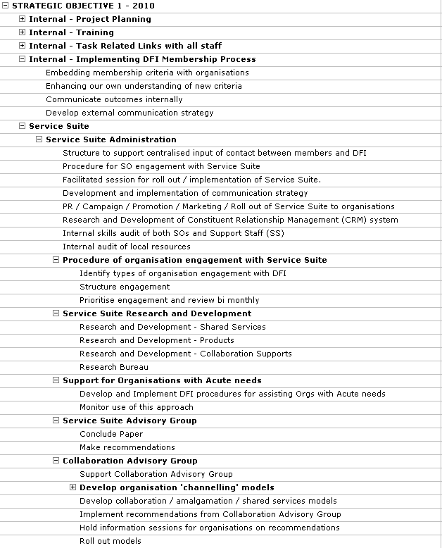
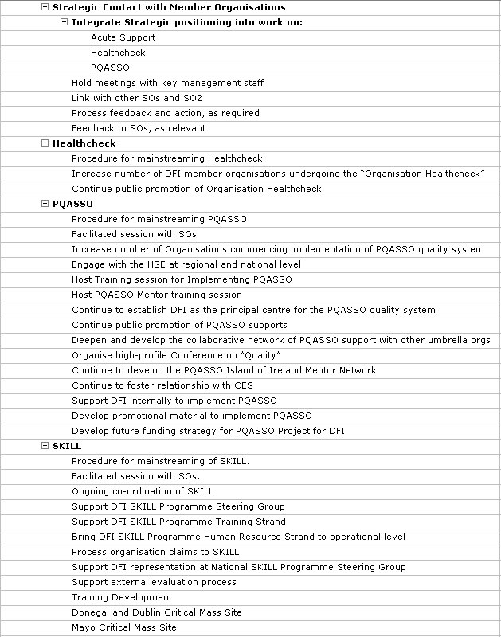
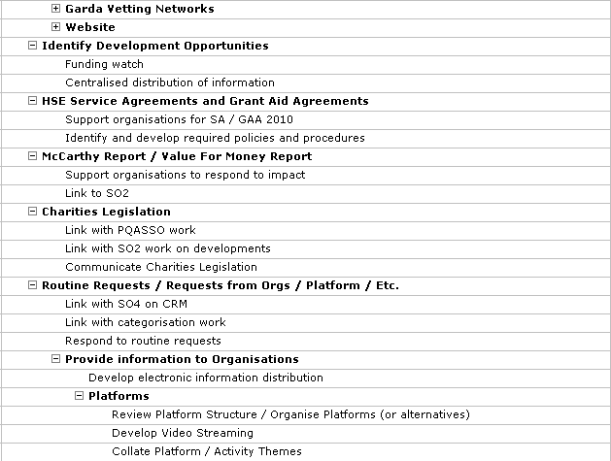

Strategic Objective 2: Influencing Policy.

1. Strategic Plan
‘Influence and contribute to Government Policy in respect of people with disabilities’ (4.2 Strategic Plan ’04 – ‘10)

2. Operational Plan 2008 –2010

Targets

Noting the progress to date, DFI will have significantly advanced the implementation of policy achievements having regard to the specific aspects of this objective as set out in the Strategic Plan, namely:
- Build and consolidate relationships with key personnel in strategic roles within Government Departments, HSE, Local Authorities, other statutory agencies, members of the Oireachtas, and by influencing the social partnership process. (4.2 (i))
- Use existing fora to raise awareness about current levels of service provision nationwide (4.2 (ii))
- Continue to lobby for a rights-based approach to services for people with disabilities and collaborate with other bodies and agencies in this regard. (4.2. (iii))
- Seek, where possible, to influence policy development, particularly:
  - Legislative reform
  - The National Anti-Poverty Strategy
  - The implementation of the White Paper, Supporting Voluntary Activity
  - The implementation of the Health Services Reform Programme and the Health Strategy
  - The work of the National Disability Authority (NDA)
  - The development of information, advice and advocacy services by CIB (4.2. (iv))
- Analyse and report on the experience of member organisations on the ground in relation to access to services for people with disabilities. (4.2.(v))
- Promote and carry out targeted research to track progress on policy implementation and service development. (4.2(vi))
- Prepare focused and research-based reports and submissions, e.g. Pre-Budget Submission. (4.2(vii))
- Develop and consolidate international links with similar agencies and networks. (4.2(viii))

Furthermore, in the context of the “Review of DFI’s Operational Plan 2005-2007) (Sept ’07), and the changing environment for the disability sector, DFI will have regard to the following;
- That the interests of people with disabilities are no longer ‘outside’ the mainstream policy environment.
- That we are now challenged to deliver the considerable amount of commitments and programmes in place.
- That we and our member organisations need to develop appropriate tools to monitor and progress the varied points of the National Disability Strategy (NDS).
- The need to influence the changed policy context having regard to the new policy instruments in the NDS and Towards 2016.
- Working in partnership with Government Departments and agencies to secure social inclusion for people with disabilities.
- Securing appropriate representation of the member organisations in the planning and delivery of services both disability specific and mainstream.
- Identifying international policy developments and their influence upon the Irish policy context.

Expected Outcomes
- That the implementation and progression of key policy and planning documents (NDS, Towards 2016, Sectoral Plans) will be monitored and analysed by DFI.
- People with disabilities will benefit from enhanced levels of services, both mainstream and disability specific, with particular reference to the areas of Health, Local Government, and Social Inclusion.

Key Performance Indicators

NDS/ Towards 2016

DFI in its commitment to monitor, will have participated in structures set up through Social Partnership and the NDS.

DFI will have provided organisations with appropriate supports to ensure that they have a greater understanding of the policy implications arising from the NDS and Towards 2016

Evidence that organisations will have played an increasingly important role in supporting the implementation of the NDS and Towards 2016.

DFI will have worked collaboratively with other groups and agencies to secure the delivery of commitments.

DFI will have engaged with relevant statutory bodies to help ensure that they honour commitments set out in the NDS and Towards 2016

Health
- DFI will have worked to strengthen national and local relationships between the HSE and disability organisations to ensure the delivery of necessary services to people with disabilities.
- DFI will have worked with organisations to secure adequate funding for voluntary disability organisations to deliver disability specific services and to enhance their role as activators in supporting people with disabilities to engage with mainstream services.
- DFI will have worked to ensure that people with disabilities benefit from general health strategies and mainstream developments in health services.
- Evidence of increased levels of collaboration between voluntary disability organisations and the Primary, Continuing and Community Care (PCCC) structures, Local Government Implementation
- DFI will have supported voluntary disability organisations to develop and deepen relationships with local government structures.
- DFI and its member organisations will have evidence that they represented and promoted the inclusion of people with disabilities during the 2009 local elections.

Social Inclusion
- DFI will have assisted member organisations to support people with disabilities to access, and benefit from, mainstream services.
- DFI and member organisations will have worked to develop relationships and to influence mainstream service providers, both statutory and voluntary to ensure that the needs of people with disabilities are addressed
- DFI and member organisations will have worked to influence the Housing Strategy, the Independent Needs Assessment (INA), the Personal Advocacy Service, developments within Departments arising from the Sectoral Plans, and the Disability Stakeholders Group (DSG) monitoring process
- DFI will have worked to influence and progress the Government’s commitment to address the issue of a Cost of Disability payment

3. 2010 Annual Plan Actions

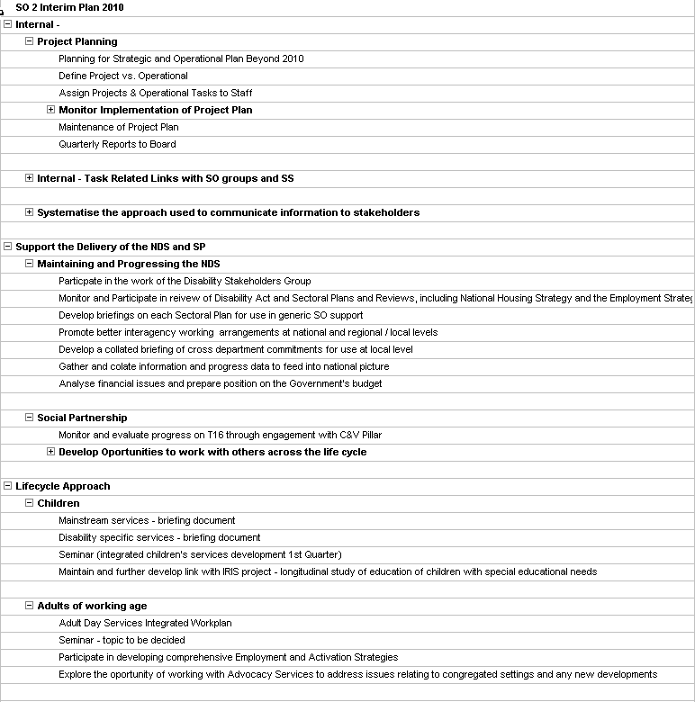

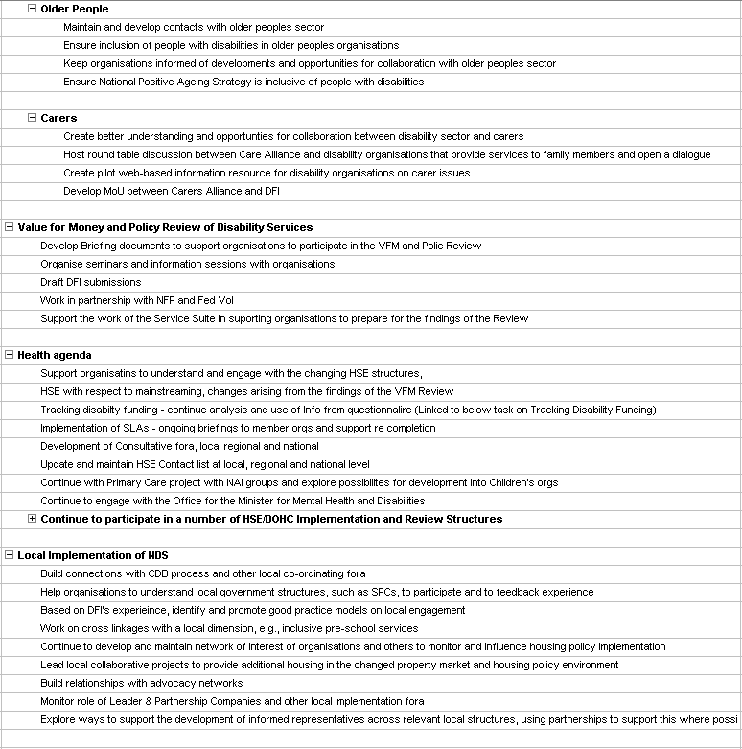
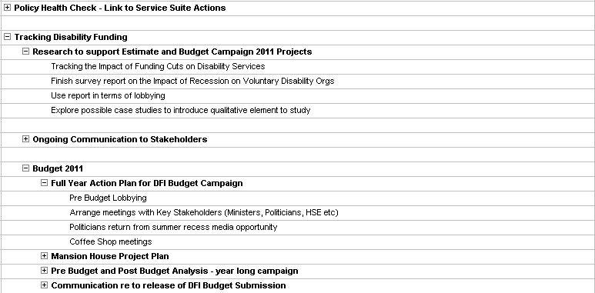

Strategic Objective 3: Building a National Platform

1. Strategic Plan
“Develop and consolidate a National Platform which articulates the views and perspectives of the disability sector in Ireland” (4.3 Strategic Plan ’04 –’10)

2. Operational Plan 2008-2010

Targets
DFI will continue to develop a platform which articulates the views and perspectives of the voluntary disability sector in Ireland and that complements the work of individual voluntary disability organisations and other umbrella / representative structures within the overall context of working towards the effective implementation of the NDS.
Noting the progress to date DFI will have contributed to the development of a National Platform having regard to the specific aspects of this objective as set out in the Strategic Plan, namely:
- Actively involve all member organisations in identifying and promoting issues and concerns (4.3(i) )
- Expand DFI membership (full and associated) (4.3 (ii) )
- Develop partnerships and strategic alliances with other disability organisations at national and regional levels (4.3 (iii) )
- Develop strategic alliances with the broad community / voluntary sector (4.3 (iv) )
- Disseminate relevant research findings (4.3 (v) )
- Develop and maintain a strong media presence (4.3 (vi) )
- Involve member organisations in all media campaigns and, in particular, at regional and local levels (4.3 (vii)
Working to build a National Platform to date has been undertaken through ensuring that what we are doing in the area of supporting organisations and policy is done in a thoughtful and inclusive way where we are always trying to find the overarching and binding elements.
Furthermore, in the context of the ‘Review of DFI’s Operational Plan 2005 – 2007’ (Sept 07) and the changing environment for the disability sector, DFI will have regard to the following:
- The energy and focus in this area needs to be strongly related to consistently creating and building relationships of trust and understanding. While this work cannot be done in the short term it is largely dependent on the reputation accredited to DFI by other organisations.
- There are practical issues to be addressed around the capacity of administration and support systems within organisations - areas where Government is still very slow to invest.
DFI continues to highlight issues which have an impact across the broad disability spectrum such as implementation of the NDS, under resourcing of organisations for current services and the introduction of the Cost of Disability Payment all of which give practical expression to this objective.

Expected Outcomes
- Consolidation of working relationships which are developing between DFI and other disability representative/umbrella organisations and organisations within and relevant to the Community and Voluntary Pillar as a priority.
- Strengthen and support the level of coherence and clarity within the voluntary disability sector particularly at the level of individual organisations in relation to their key role in supporting people with disabilities within the mainstreaming context.
- Increased articulation within and across voluntary disability organisations of the needs and circumstances of people with disabilities in Ireland.
- Increased networking, coordination, cooperation and collaboration within the DFI membership.

Key Performance Indicators
- The development of memoranda of understanding and other working arrangements along with evidence of joint engagement and work.
- The active participation of DFI in relevant representative/umbrella organisations
- DFI will have continued to contribute to the social partnership process in Ireland
- Evidence of supports given by DFI to individual organisations and the sector through the organisation of specific events, through the production of resource materials, through the commissioning of research, through the sharing of information and good practice
- Evidence of progressive realisation of mainstreaming as cited by our organisations having regard to key issues such as health, education, employment, social inclusion and organisational capacity / development.
- DFI will have pulled together and analysed information which is relevant to people with disabilities in Ireland
- DFI will have developed more effective media and communications strategies in order to articulate the needs and circumstances of people with disabilities.
- DFI member organisations will have a clearer understanding and awareness of the benefits and advantages of inter-organisation collaboration
- Evidence of increased co-operation and collaboration amongst DFI member organisations.
- Using the research currently being undertaken by DFI and through other initiatives DFI will develop mechanisms against which progress in relation to co-operation and collaboration can be benchmarked

3. 2010 Annual Plan Actions

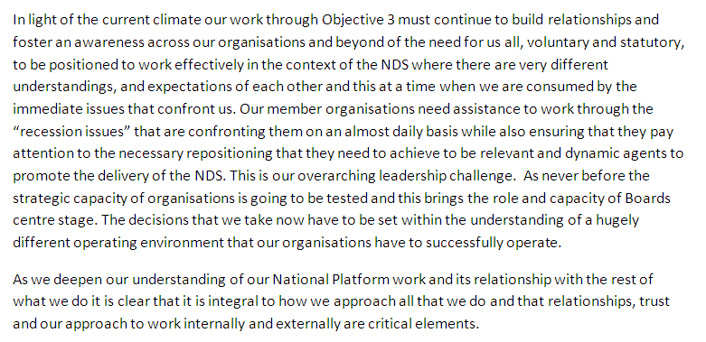
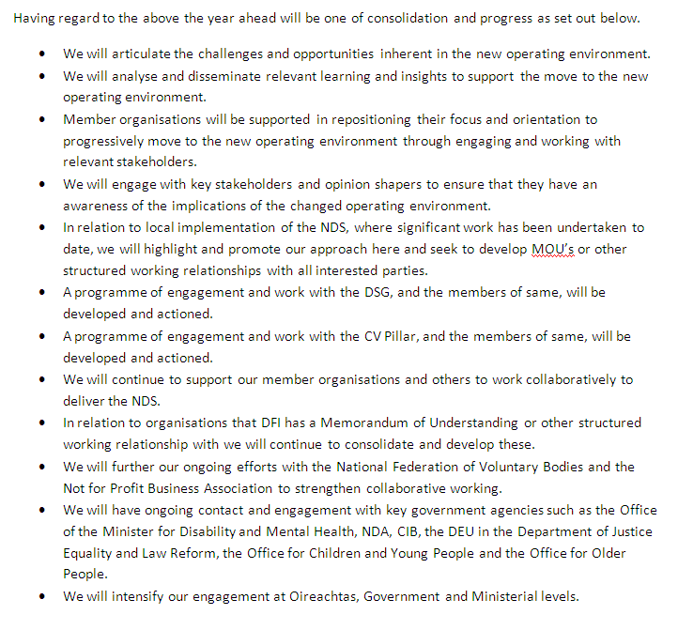

Strategic Objective 4: Strategic Implementation Framework.

1. Strategic Plan
“In order to maximise its potential in respect of the first three strategic priorities, DFI will engage in capacity building and organisational development” (5.1(i) Strategic Plan ’04 –’10)

2. Operational Plan 2008-2010

Targets
Noting the progress to date DFI will have maximised its ability to deliver on the three strategic objectives (Organisational Services and Supports, Policy and National Platform) by successfully engaging in capacity building and organisational development; developing staff related supports and structures; and developing alliances and relationships while having regard to the following specific aspects of this objective as set out in the Strategic Plan, namely;

Organisational Structures
- Review its system of governance with particular reference to the changing profile and focus of disability organisations. (5.1(ii))
- Develop an ongoing operational plan with in-built evaluation as appropriate. (5.1(iii))
- Review internal structures and decision-making processes. (5.1(iv))
- Instigate quality assurance protocols. (5.1(v))
- Develop additional data collection mechanisms, particularly by documenting and analysing the experience of organisations providing frontline services. (5.1(vi))
- Develop additional mechanisms for communication with and feedback from Council Members. (5.1(vii))
- Review and revamp its information management systems and publications. (5.1(viii))
- Review and extend the membership base of the organisation. (5.1(ix))
- Build stronger links with other voluntary/community organisations. (5.1(x))
- Review and develop databases and IT systems to be used internally and externally. (5.1(xi))
- Continue to develop and update DFI website. (5.1(xii))
- Strengthen and consolidate media contacts. (5.1(xiii))

Staffing
- Continue to employ professional and skilled staff to provide quality services. (5.2(i))
- Review its current staff structures and deployment and pursue any implications and changes necessary in consultation with relevant stakeholders. (5.2(ii))
- Implement and maintain a set of clear and comprehensive Human Resource systems and procedures. (5.2(iii))
- Implement staff training programmes which will provide:
  - Skills in best practice models of operation.
  - Modules on contemporary business management practices.
  - Updates on relevant developments in Ireland and internationally. (5.2(iv))

Alliances
- Explore links with selected agencies outside Ireland in relation to service and policy developments. (5.3(i))
- Develop and enhance links with people in academic arenas working in the area of equality and disability. (5.3(ii))
- Maintain and develop membership of other fora, which promote the development of services and supports for people with disabilities. (5.3(iii))
- Strengthen links with Government Departments and statutory agencies. (5.3(iv))
- Build and enhance relationships with other voluntary sector organisations. (5.3(v))
- Enhance relationships with existing and potential statutory funders particularly:
        - Department of Health and Children
        - HSE
        - Department of Social and Family Affairs
        - Department of Community, Rural and Gaeltacht Affairs
        - Combat Poverty Agency
        - Citizens Information Board (5.3(vi))

Furthermore, in the context of the “Review of DFI Operational Plan” 05- ’07 (Sept ’07) and the changing environment for the disability sector, DFI will have regard to the following;
- That increased resources and management are required.
- That our staff complement increased by 33% over the past three years and that we need to plan on the basis of further growth.
- That while we have been successful in making a change in relation to ICT support that similar changes are required in relation to the overall corporate services area.
- That Corporate Services will be effectively providing the necessary organisational capacity thereby ensuring that we have a vibrant, responsive and proactive organisation which is knowledge and information rich and where the use of ICT is maximised.
- To have a staff team that is innovative, responsive and learning in its work.
- To have an organisation which is confident on the basis of evidence and expertise about where the membership organisations, and the sector in general, needs to focus in relation to upcoming opportunities and challenges

Expected Outcomes
- That Corporate Services will be effectively providing the necessary organisational capacity thereby ensuring that we have a vibrant, responsive and proactive organisation which is knowledge and information rich and where the use of ICT is maximised.
- To have deepened the understanding of the respective roles and functions of National Council, Board and Executive as well as the capacity of the Executive, Board and National Council in relation to operating best practice Governance procedures.
- To have a staff team that is innovative, responsive and learning in its work.
- To have an organisation which is confident on the basis of evidence and expertise about where the membership organisations, and the sector in general, needs to focus in relation to upcoming opportunities and challenges.

Key Performance Indicators
- The establishment and operation of a Corporate Services function adequately staffed and led by a person at senior management level.
- Evidence of the ability of DFI to pre-empt, avoid and/or recover from critical situations.
- Evidence of the production and dissemination, in an effective and efficient manner, of information to support member organisations.
- Evidence of the ongoing use by staff and member organisations of the resources and supports provided by DFI.
- A well motivated, committed and skilled staff team.
- Evidence of problem solving and / or other innovative suggestions.
- Evidence of enhanced team working.
- Evidence of learning and good practice from one project to another.
- Evidence of availability of appropriate information and research being collected and disseminated.
- Evidence of critical analysis being used in relation to outstanding needs and requirements within the disability sector
- Evidence of successfully identifying upcoming issues, challenges and opportunities for the sector.
- Evidence of DFI taking proactive initiatives and actions.

2010 Annual Plan Actions 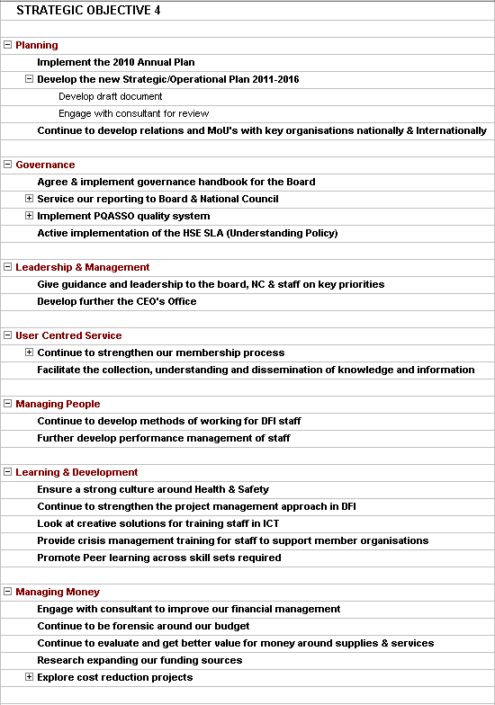
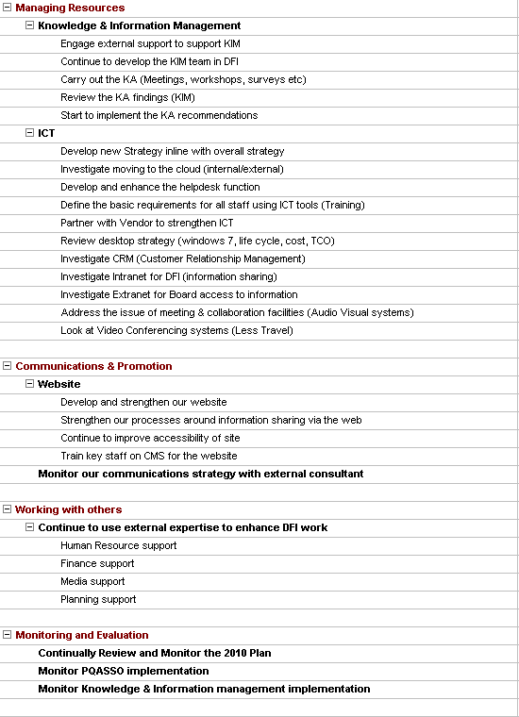

End of Document

