Time for Action – Investing in Disabled People

Pre-Budget Submission 2024

Section 1: Introduction
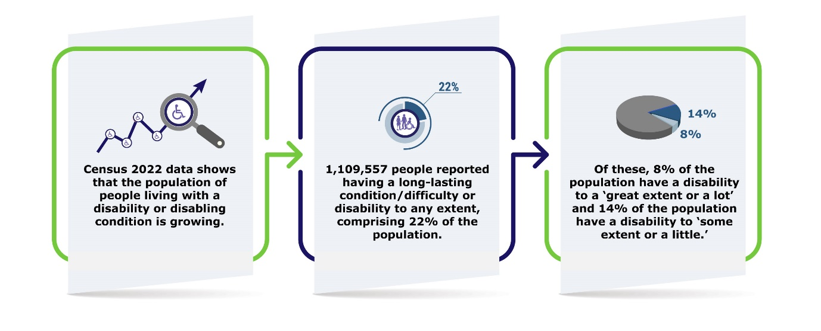

People with disabilities continue to live with high levels of poverty and exclusion. While our domestic economy grows and Irish finances are in rude health, current social protection supports maintain thousands of disabled people in poverty. Ireland is also at the bottom of the EU league table in relation to the disability employment gap.
While the government is placing an emphasis on economic sustainability, the same attention must be given to social cohesion, prioritising increases to social protection payments and funding for crucial services in line with the rising cost of living. This would support the realisation for disabled people of the goals of the government’s recently published Wellbeing Framework 2023. The Framework focuses on quality of life, with a particular emphasis on equality and sustainability, and itself recognises that people with disabilities “experience inequality across a high proportion of indicators”.
Ongoing structural inequalities prevent disabled people from realising their equal rights as citizens. Many struggle to secure suitable housing to live in due to a shortage of accessible and affordable homes, alongside necessary community supports. A lack of fully accessible public transport means people with disabilities do not have free movement. Disabled people also encounter significant waiting lists and lack of state provision of sufficient health, community, personal assistant, and social care supports.
Crucial to independent living is the provision of funded community services. Currently a significant majority (70%) of disability services are provided by the voluntary sector. This is a particular concern as voluntary disability organisations are experiencing a crisis in the recruitment and retention of staff, due to low levels of available skilled workers and insufficient levels of funding for section 39 funded organisations. This causes disparity in pay, making it impossible for organisations to compete with better terms and conditions on offer for similar roles in the public sector. Ultimately this negatively impacts the quality and sustainability of services and supports for disabled people, exacerbating exclusion and reducing wellbeing and quality of life.
“In the last year the organisation has struggled to fill key roles. This has included front-line support worker roles who are critical to our ability to deliver safe, effective support. In one service area in 2022 the organisation had to step back from delivering support.”
DFI Member
Action is needed in all of these crucial areas to enable disabled people to live independently and equal to others, a commitment which Ireland made when it ratified the UN Convention on the Rights of People with Disabilities, UN CRPD.

1.1 Current Status: Disability Exclusion and Poverty
Many people with disabilities live precarious lives. Ongoing systemic problems exacerbate the marginalisation and exclusion being experienced. For example:
- Disabled people live with extra costs of approximately €8,700 - €12,300 a year, that are not covered by existing social welfare provision (Indecon, 2021).
- Ireland ranks 24th of the EU 27 for disability poverty, and lowest in the EU for disability employment rates and the disability employment gap (Roadmap for Social Inclusion Progress Report, EDF 2023).
- One in two disabled people who are unable to work (44.3%) live in deprivation (CSO SILC, 2022).
- 1,250 people with disabilities under the age of 65 are inappropriately living in nursing homes (RTÉ via FOI, 2023).
- The number of disabled people on the housing list declined by half as much (5%) as those without disabilities (10%) in recent years (Housing Agency, Summary of Social Housing Assessment, 2020). Some disabled people report being on the waiting list for up to 10 years.
- 5,521 (9.5%) households have disability as the main category of need for social housing support (Housing Agency, Summary of Social Housing Assessments, 2022).
- 64% of the HSE Disability Services budget supports about 8,300 people with disabilities in residential services (Disability Capacity Review, 2021).
- Almost 70% of disability services are provided by the voluntary sector (Disability Capacity Review, 2021).

1.2 Progressing the UN CRPD – Five Years On
The Dáil unanimously ratified the United Nations Convention on the Rights of Persons with Disabilities, UN CRPD, in March 2018. The Convention commits signatories to a comprehensive set of actions required to bring about the necessary changes to support the equal participation, rights and inclusion of people with disabilities. This year marks the fifth anniversary of Ireland’s ratification of the UN CRPD, and a chance to look back on the progress so far, and what still needs to be done. Unfortunately, progress has been slow, and there is still much to do to realise the rights of disabled people.
Since its ratification we have seen some strong commitments to improve disability supports, and changes to infrastructure and approaches to disability in Ireland. These have included:
- New Ministerial briefs focused on disability.
- Creation of the new Department of Children, Equality, Disability, Integration and Youth (DCEDIY).
- Transfer of disability departmental functions from the Department of Health to DCEDIY.
- Establishment of the Oireachtas Disability Matters Committee, and
- Creation of the Disability Participation and Consultation Network.
The long-pending transfer of specialist disability services from the Department of Health to the DCEDIY in March 2023, while still in its initial stages, is a welcome development, and offers positive opportunities for change. DFI has welcomed disability now being homed in a department whose core brief includes equality, and the focus on a UN CRPD informed approach, as well as the potential for better coordination from one anchor Department. On the other hand, concerns remain as to how the new areas of responsibility will be effectively integrated into DCEDIY’s remit, and crucially how coordination will happen with the Department of Health, which still has responsibility for key areas of mainstream health provision which the vast majority of disabled people rely on.
Concerningly, progress is slow or stalled in a number of important policy areas. For instance, we are waiting for:
- Ireland’s UN CRPD implementation plan.
- A Cost of Disability implementation plan, following the Department of Social Protection’s 2021 Indecon Cost of Disability Report.
- The Disability Capacity Review Action Plan.
- Disability services strategic workforce planning to address supply and pay issues in the sector.
- The Reasonable Accommodation Fund Review and Comprehensive Employment Strategy 2022-2024 Action Plan.
- The findings of the Housing Adaptation Grant Review, and full implementation of the National Housing Strategy for Disabled People.

1.3 A Clear, Transparent and Disability Proofed Budget
If all budgetary and other relevant decisions are subject to meaningful and consultative equality proofing, including disability proofing, there would be greater clarity on the likely impact of budgetary measures for disabled people.
Previous budgets have not been clear or transparent about the impact of measures on critical services, or the funding allocated. This has been further exacerbated by delays in the publication of the HSE National Service Plan, creating additional uncertainty and a disruptive time lag in clarity about service allocations.

DFI calls for a clear Budget Day announcement in October, so that disabled people and the organisations that support them can understand the implications of the budget - particularly in relation to the areas of health and housing.

Section 2: Budget 2024 - Rebuilding Sustainability to Invest in Our People
Budget 2024 is the first opportunity for the Department of Children, Equality, Disability, Integration and Youth to demonstrate its commitment to disabled people. It is also one of the last chances to implement the Programme for Government commitments.
DFI is calling for a range of interwoven measures in Budget 2024 to ensure disabled people have the opportunity to live independently in the community, with choices equal to others (Article 19, UN CRPD). Appropriate housing, adequate income and individualised social care supports (with access to timely integrated healthcare) will prevent unnecessary admissions to nursing-homes and go some way towards achieving independent living for disabled people.
In Budget 2024, DFI calls for investment in the following essential areas.

Sustainable Disability Health and Social Care Services (UN CRPD Articles 19, 25 and 26)
Alongside the implementation of Sláintecare and development of new Health Regions, integration of disability services is paramount to ensure the best outcomes for disabled people. Given the majority of disability services are provided by voluntary disability organisations, a priority for government must be to resource and support a sustainable voluntary sector.
Health and social care Budget planning is hindered by the delayed publication of the Disability Capacity Review Action Plan. Despite the initial commitment that it would be completed by December 2021, it appears that the long-awaited Action Plan will not be published until after this year’s Budget process. This is very concerning, as it would be the third year when the government’s own mapping of disability need is not used to inform its investment in disability. The Action Plan is necessary to invest, develop and deliver disability services. Findings of the Capacity Review show high levels of demographic and unmet need, which will increase in the future. We are deeply concerned that this delay will prevent much needed investment for another year. It also means that disability organisations like DFI lack vital information on which to base our budgetary asks.
Increased and multiannual funding is required to support equal access to services in line with demographic trends in disability and population growth. Disability services that are essential to the right to independent living, including Personal Assistant Services, PAS, home supports, alternative forms of respite, personalised budgets etc. are underfunded and overstretched. Funding is also required to deliver equal access to services across the whole lifespan regardless of geographical location. The transfer of disability services to DCEDIY also brings an opportunity to focus on funding and developing innovative service models in line with the person-centred approach promoted by the UN CRPD.
“We are a small charity and reliant on continued funding from the HSE and other partners. This funding can be precarious and not guaranteed and can be withdrawn suddenly, so uncertainty is often an issue with the staffing.”
DFI member
Over 90% of people with disabilities are supported through mainstream health and community services, rather than specialist disability services. Almost all people with disabilities will depend on access to mainstream health services at some point in their life. Ensuring integration between specialist disability services and mainstream health services will be key in the context of the transfer of the HSE Disability Services programme to DCEDIY. There are ongoing issues with access to mainstream health services including staff shortages, long waiting lists and lack of funding and resources. Addressing the needs of disabled people must be a central element of Sláintecare implementation. This also needs to be carefully considered and planned for in the development of the Health Regions.
“I don't know what's worse than a crisis, but we are facing it now … as we try to sustain our service to disabled people."
DFI Member

2.1.1 The Impact of Staffing Retention and Recruitment
Essential services are threatened by a recruitment and retention crisis. Almost 70% of all disability community services are provided by voluntary disability organisations. The impact of the staffing and recruitment crisis on these organisations is creating a huge risk to their ability to provide adequate services to adults and children with disabilities. Many disability organisations may not be financially viable into the future, hugely impacting people who rely on these services.
The recruitment and retention crisis is exacerbated by insufficient pay and working conditions in Section 39 funded organisations, where funding and pay cuts during the financial crisis have never been restored. As a result, they cannot compete with the significantly better pay and conditions available for similar roles in the HSE or Section 38 funded organisations. Ireland is at full employment and the issue of supply of workers to fill posts is a disability sector-wide concern. This puts additional pressure on voluntary disability organisations to keep the workforce they have in a highly competitive environment. The issue of pay disparity must be addressed by government so that Section 39 organisations are equally attractive workplaces for staff.
These challenges are having a devastating impact on delivery of supports, leading to disruption, lack of continuity of staff and cutting back of services in some cases.
“I have really significant, irreplaceable staff coming to me in tears saying they love their jobs, that they don't want to leave, but the differential between what they get in pay and conditions in Section 39 and what they can get in Section 38 and from the HSE is just too wide. The economic factors leave them with no choice and we are faced with reducing and curtailing services."
DFI Member

A recent survey of DFI members (2023) shows that, of those who responded:
- 59% have concerns over the sustainability of their organisation due to retention of staff.
- 48% have reduced the level of service they offer due to reduced staffing levels.
- 62% have run an unsuccessful recruitment campaign in the last 12 months and posts remains unfilled.
- 71% have lost experienced staff to the public sector.
- 57% have lost experienced staff to the private sector.
- 43% have lost experienced staff to non-healthcare related posts.
- 33% (over one in four) have lost experienced staff due to burnout.
- 70% have concerns regarding the additional risks their organisation is carrying due to staffing issues.
While the pay gap between Section 39 funded organisations and the public sector continues to widen, voluntary organisations also operate with historic funding deficits and the increasing cost of compliance due to growing regulations that organisations are not funded to meet. Inflation also continues to place pressure on organisations, particularly in relation to energy costs.
Funding to voluntary organisations should cover the full cost of delivering services, including pay alignment with the HSE and meeting non-pay costs such as compliance related costs, electricity, insurance etc.
“The funding for Section 39 organisations has not been restored since the recession. But the HSE budget has doubled from €13 billion to 23/24 billion (between 2013-2022). Little or none of that additional funding has found its way back to Section 39 organisations, whose staff took just as much pain and hardship as HSE and Section 38 staff did during the recession."

Fran Brennan, CEO, Polio Survivors Ireland and Chair of the Board of DFI

In Budget 2024, DFI calls for:
- Funding for Section 39 funded organisations to ensure their sustainability. Provide funding to increase pay by 15%, and reinstate the link to public sector pay for disability organisations.
- Sufficient investment to deliver the Disability Capacity Review and the swift publication of the Disability Action Plan. This includes building and strengthening comprehensive critical supports in the community such as personal assistant and home care services; respite; day services; residential services; multidisciplinary therapy services and a wide range of community supports.
- Repeat last year’s €63m one-off inflation fund for community and voluntary disability organisations to address significant, ongoing inflation pressures.
- Provide a disability funding stream as part of the Sláintecare Integration Innovation Fund to drive best practice in the integrated care pathways for disabled people.
- Invest €26m to fully roll-out Community Neurorehabilitation Teams in every Community Health Organisation. This will include funding for Speech and Language Therapists, Occupational Therapists, Physiotherapists and Clinical Psychologists. Only 15% of patients currently have access to a community neurorehabilitation team, with only two of the promised nine teams delivered across CHOs.
- Provide €17.5m to support disabled people under 65 to move out of nursing homes into appropriate housing, and to develop alternative housing and support pathways to stop more people entering nursing homes.
These measures are necessary to tackle ongoing inequality, to deliver wellbeing and increase quality of life; enabling disabled people to live in the community, equal to others.

Tackling High Poverty Levels and Cost of Disability (UN CRPD Articles 28, 19 and 27)
“The cost of living is very bad, and I worry day-to-day constantly about it, that I won't have enough money to heat my house. People are going to just suffer this year in this winter, especially people with disabilities. I really worry about what’s in the future for me and other people with disabilities.”
Catherine Cooper, disability self-advocate

To be disabled is to experience a much higher risk of poverty, and/or deprivation; where affording the ordinary things in life is a major challenge – securing a home, taking a holiday, buying new clothes or keeping up with your utility bills. The inflation and cost of living crisis has exacerbated the ongoing, systemic economic vulnerability faced by disabled people who rely on our social protection system to survive.
A recent European Disability Forum report showed that Ireland ranks the lowest in the EU on disability employment. The government’s Roadmap for Social Inclusion Progress Report shows that we rank 24th in the EU for disability poverty, with an ‘at risk of poverty’ rate almost 10% above the EU average, despite Ireland being one of the wealthiest countries in the EU.
Disabled people live in all communities in Ireland, and there is a social consensus in the Oireachtas and among the general public that they should be supported and have an income sufficient to protect them from poverty. Given this, and the healthy state of the Irish economy, it is alarming that while on average 29.7% of the EU population with a disability were at risk of poverty or social exclusion (AROPE) in 2021, Ireland’s rate was almost 10% higher, at 39.3%. Only Bulgaria, Latvia and Romania had worse disability poverty levels than Ireland.
The 2022 CSO national SILC poverty and deprivation data also provides important evidence to illustrates the seriousness of the problem. It shows that people unable to work due to long-standing health problem (disability) have:
- The highest consistent poverty rates of all economic groupings at 19.7%, or one in five people.
- Rates, almost four times the national average (5.3%) for consistent poverty.
- The second highest at risk of poverty rate at 35.2%, compared to the national average of 13.1%.
- A much higher risk of living in deprivation, with one in two people (44.3%) living in deprivation, compared to the national average of 17.7%.

The data also show that people unable to work due to long-standing health problems (disability) live with extreme deprivation:

- 19.6% are unable to afford to keep the home adequately warm, compared to 5.7% of employed people.
- They are eight times more likely to be unable to afford a meal with meat, chicken, fish, or vegetarian equivalent every second day than the national average.
Also, the percentage of this group who were unable to afford to keep their home adequately warm increased by more than 10% in the past two years – from 8.5% in 2020 to 19.6% in 2022. It paints a very poor picture of modern Ireland that people who cannot work because of their disability or health condition are not eating properly and cutting back on essential heating due to a lack of sufficient income.
Ireland has promised to address this. The Roadmap to Social Inclusion commits to:
- Reduce the AROPE (At Risk of Poverty and Social Exclusion) rate from 36.9%, first to 28.7% (2025) and then to 22.7% (2030).
- Increase the employment rate from 22.3%, first to 25% (2021) and then to 33% (2027).
However, the Second Roadmap Progress Report shows that despite these very clear targets, things are in fact getting worse. Ireland’s AROPE rate increased by almost 5% in 2021. Ireland ranks 24th of the EU 27, even though we are one of the wealthiest European countries, and our goal is to be in the top 10 by 2025. Given that Ireland’s current AROPE rate is more than 10% higher than the 2025 goal, concerted action and resources will be needed in Budget 2024 to deliver the promised decrease in disability poverty.
Ireland performs extremely poorly at EU level on disability employment also. The previously mentioned European Disability Forum report (2023) shows that Ireland ranks the lowest in the EU for both its disability employment rates, and for its disability employment gap. The EU Commission has been highlighting concerns about this during the EU Semester process over consecutive years. The 2023 Country Specific Report (CSR) for Ireland emphasises the very low employment rates of disabled people (with this being one of only 2 indicators on Ireland’s social scoreboard marked red), and expresses concern that while overall poverty rates improved, “disadvantaged groups [including disabled people] became poorer”.
An ongoing issue that perpetuates poverty is the additional cost of disability. The 2021 INDECON Report on the Cost of Disability, commissioned by the Department of Social Protection, provided comprehensive policy evidence that people with disabilities have extra costs across areas including mobility, transport, communications, care and assistance services, equipment, aids and appliances, and medicine. The report concluded that “there are significant additional costs faced by individuals with a disability which are currently not met by existing programmes or by social welfare payments [our emphasis].” The report indicates extra costs in the range of €8,700-€12,300, and recommends tackling this through increased cash payments, enhanced access to services and targeted grant programmes. It is important to note that the basic annual income currently provided by the state through the Disability Allowance, €11,440, would in some cases not cover additional disability related costs, let alone everyday living costs.
Disability and anti-poverty organisations have for many years called for a weekly Cost of Disability payment as a first step in acknowledging these extra costs. The one-off €500 Disability Support Grant in Budget 2023 was a welcome first acknowledgement of these costs. But ongoing, permanent, and sufficient support to mitigate the cost of disability is required into the future to avoid perpetual disability poverty. This would also be a worthwhile investment as it could support many disabled people to enter the workforce and/or be more active in their community.
The inadequacy of social welfare rates has been highlighted in recent years, both by the gap between core rates and the higher rate of the Pandemic Unemployment Payment, and by the cost-of-living crisis, bringing an important focus on the necessity of indexing social protection payment levels. Disability and anti-poverty organisations have for many years called for a Minimum Essential Standard of Living, to ensure those who rely on our social protection system to survive are not condemned to poverty.
In Budget 2024, DFI calls for:
- A recurring Cost of Disability payment of, at a minimum, €40 a week, building on the Cost of Disability one-off grant announced in Budget 2023.
- In addition, an increase in the Disability Allowance and other core disability payments of at least €27.50 a week. Due to the cost-of-living crisis, anything less than this will be a real term cut. This is the absolute minimum required to prevent individuals and families being pulled deeper into poverty.
- Develop a specific poverty reduction strategy for disabled people, given their disproportionately high poverty rates and the Roadmap to Social Inclusion commitments. Lay out the steps and actions to be taken each year to deliver the poverty reduction targets, and allocate sufficient funding to 2025 to deliver them.
- Ensure support for energy costs are set at an adequate level: increase the annual value of the Fuel Allowance by €680.40 to restore its purchasing power, i.e. a weekly increase of €24.30 for a 28 week season. Consider restoring the 32 weeks of payment to better reflect the heating season.
- Develop and resource a clear Action Plan to fully address the Cost of Disability over the next 3 years.
- Continue to prioritise and use responsive targeted measures to support disabled people with the cost-of-living crisis, including addressing Energy Poverty issues, particularly in Winter 2023.
- Social welfare rates must be benchmarked to a level above the poverty line and considering inflation, while taking the Cost of Disability into account. Use the Minimum Essential Standard of Living (MESL) recommendations as a guide for the level of social protection needed.

Ensuring Community Inclusion and Participation (UN CRPD Articles 8, 9, 19, 21, 29, 30)
Facilitating people with disabilities to live equally in communities is one part of an overall process towards equality and inclusion. There is a core difference between living in the community and being part of the community.
Organisations who support disabled people are reporting an increase in social isolation. To combat this, community services must operate and be designed in a way that facilitates the participation of disabled people. Physical accessibility and mainstreaming of Universal Design as well as access to information in accessible, and easy to read formats, should be prioritised.
Strong cross-Departmental and cross-agency working is required to achieve a more inclusive society. For example, health services and local authority housing staff collaborating to enable independent living at home. This collaborative working helps to ensure that disabled people are not socially isolated in their communities. Resourcing is therefore required to ensure public services such as housing, transport, education etc. can respond to the needs of disabled people, on an equal basis to others.
Key funding decisions which shape community life are increasingly being made through, and in partnership with, Local Authorities and Local Community Development Committees (LCDC’s). These include decisions on how key rural and local development funding is spent and how local actions to address social exclusion are rolled out, through for example, the SICAP and LEADER programmes. Strategic decisions around infrastructure such as accessible public transport, public amenities, employment training and education opportunities would ensure communities are accessible for all.
Local Government is responsible for the participation and engagement of all local citizens in these decisions. The ratification of the UN CRPD and Public Sector Duty requirements serve to reinforce those duties. Structures which enable participation at local level, such as Public Participation Networks, Strategic Policy committees and issue specific decision-making structures should be supported and resourced to include the voice of disabled people.
It is also essential that Ireland embeds inclusion in the ongoing sustainable community development agenda, considering disability inclusion in developments in ICT, transport, the built environment, and the redesign of public spaces, into the future.
Ireland should develop and implement participation and engagement strategies which are universally accessible and work to engage all citizens in local decision-making. For example, easy-to-read information supports those with intellectual disabilities, literacy difficulties and migrant communities. All plans and actions at local level should also be disability proofed from point of development through implementation and evaluation.
Community and voluntary agencies, public bodies and Local Authorities cannot discriminate on the basis of disability. Reasonable accommodations and disability supports may be required, to ensure that disabled people can receive services on an equal basis to others, for example access to Sign Language Interpretation and easy-to-read website content.
To help make disability inclusion a reality at community level, funding must be provided to Local Authorities and community and voluntary groups to educate about and support the inclusion of people with disabilities at community and county level.
In Budget 2024, DFI calls for:
- A Disability Inclusion Fund for all Local Authorities to support their specific disability inclusion requirements in line with the UN CRPD and Public Sector Duty. This should contain accommodations to support disabled people’s participation, e.g. sign-language interpretation. Total cost: €7m.
- Investment in increased accessibility and frequency of Local Link Transport services for disabled people living in rural areas.
- Urgent establishment of a Transport Support Scheme to replace the Mobility Allowance and other transport schemes, as per the Ombudsman’s longstanding recommendation.
- Funding of €2m for assistive technology supports, including a national network, loan library, national database, information system, training programme and peer support development programme.

Realising Housing for All (UN CRPD Article 4 and 19)
DFI and the Citizens Information Board jointly published a social policy report on housing and disability last December, which found that people with disabilities face significant challenges finding a suitable home to live in. While acknowledging the severe Irish housing crisis, the report documents the disproportionate extent to which people with disabilities are failed by the system, and the range of challenges they continue to experience.
Delays in the publication of the Implementation Plan for the National Housing Strategy for Disabled People 2022-2027 up to June 2023, requires redress through sufficient resourcing to enable immediate action. To ensure the positive ambitions of the Housing Strategy are realised it must now be rigorously implemented.
People with disabilities should have the same options and opportunities to live in and be part of a community as everyone else. This is still not a reality for many, who have very narrow and limited housing choices.
Adequate funding, effective collaboration, and robust management, oversight and reporting would facilitate implementation. Sufficient funding to provide for all areas of disability housing policy – to support the de-congregation process and move people out of nursing homes, but also to deliver sufficient fully accessible housing and the necessary support provision (including social care packages) for those who wish to live independently.

The vast majority of people with disabilities in Ireland live in the community and experience many housing challenges – mostly related to lack of sufficient resources, of universally designed housing and of joined up policymaking. 5,521 (9.5%) households have disability as their main need for social housing support. Disabled people also spend far longer on social housing waiting lists due to a lack of suitable options - the disability waiting list is reducing at half the rate of the general housing waiting list. In 2020, for example, the number of disabled people on the housing list declined by half as much (5%) as those without disabilities (10%). Some disabled people report being on the social housing waiting list for 10 years or more.
Moreover, given the ongoing demographic trends with rising numbers of people with disabilities, ensuring that all housing policy factors in disability will be crucial to delivering sustainable development, effective strategic planning, and the efficient delivery of well-planned homes in inclusive and vibrant communities.
The UN CRPD commits Ireland to promoting Universal Design. The significant level of building due to take place under Housing for All has to factor in disability and include sufficient universally designed and wheelchair liveable homes to future-proof Ireland’s housing stock. Moreover, well planned homes will be suitable for the whole lifecycle, and accessible to all.

In Budget 2024, DFI calls for:
- Funding for Local Authority Disability Friendly Housing Technical Advisor positions, to be dedicated, standalone roles. Cost: €1.8m.
- Increase the Capital Assistance Scheme funding to €150m.
- Funding to build a sufficient percentage of universally designed and wheelchair liveable (i.e. Universal Design ++) housing.
- Increase the Housing Adaptation Grant for People with a Disability to €60m and urgently reform the scheme to support adaptations of private homes.
  - Maximum grants are not keeping pace with rising construction costs and must be increased to €60,000.
  - In addition, the income threshold for the Grant should be increased and only the income of the disabled person/primary carer in the household should be assessed for the means test.
- Increase the Disabled Persons Grant and Improvements Works in Lieu Schemes to €40m to support adaption of social housing.
- A top-up Capital Investment Fund should be provided in 2024 to support disability upgrading and future-proofing of private and Local Authority homes which were not adapted in recent years due to insufficient funding within existing grant schemes.

Conclusion – Time for Action!
Earlier this year the core disability budget moved from the Department of Health to the Department of Children, Equality, Disability, Integration and Youth. Budget 2024 is the first opportunity for DCEDIY to demonstrate its commitment to disabled people.

The current government has just two Budgets left to deliver on its significant Programme for Government commitments to disabled people and their families. Five years after the ratification of the UN CRPD, Ireland is failing to make progress in important areas to deliver equality and the right to independent living for disabled people.

Given the resources available to the State and the health of our economy, the situation of disabled people must be prioritised. The time is now to invest in a sustainable future for disabled people. One in five people in all communities across Ireland, and their families, expect nothing less.
Appendix

Tables from Disability Capacity Review, published in 2021.
The tables and the Capacity Review make recommendations for increased funding in a range of areas. These tables are on page 29 of the Review.
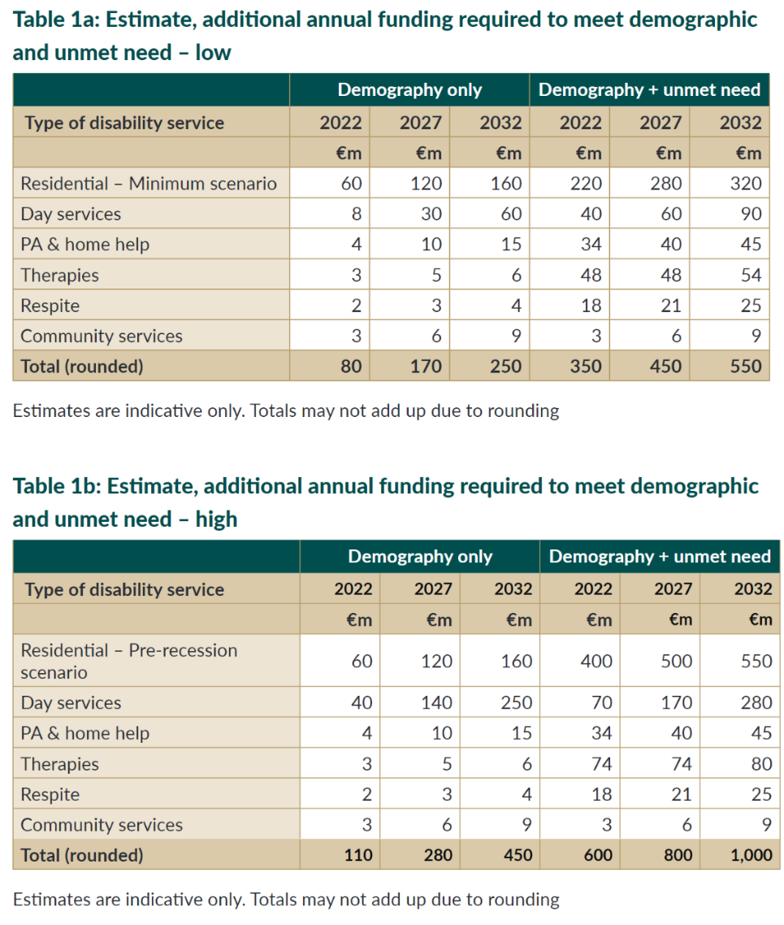

DFI’s vision
An Ireland where people with disabilities are participating fully in all aspects of society.
DFI’s mission
DFI is a federation of member organisations working with people with disabilities to implement the UN CRPD and ensure their equal participation in society.

Four-year goal
Member organisations are actively involved in DFI, working to implement the UN CRPD and to achieve the equal participation of people with disabilities in society.

DFI, Fumbally Court, Fumbally Lane, Dublin 8
Tel: 01-4547978
Email: info@disability-federation.ie
Web: www.disability-federation.ie

Registered Charity Number: 6177 Company Number: 140048
Charities Regulator Number: 20010584

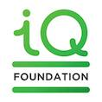
@DisabilityFed @disabilityfederationire @DFIIreland

https://www.edf-feph.org/publications/human-rights-report-2023-the-right-to-work/
Understanding Life in Ireland: The Well-being Framework 2023, https://www.gov.ie/en/press-release/5cb4b-publication-of-understanding-life-in-ireland-the-well-being-framework-2023/, p 33.
Stated in Department of Health (2021), Disability Action Plan Framework. https://www.gov.ie/en/publication/f7943-the-disability-framework-action-plan-working-group/
Disability Capacity Review
Disability Capacity Review https://www.gov.ie/en/publication/d3b2c-disability-capacity-review-to-2032-a-review-of-social-care-demand-and-capacity-requirements-to-2032/
See the recently published recommendations of TASC here - https://www.tasc.ie/assets/files/pdf/the_wheel__tasc_report_f_v_080623.pdf.
https://www.pobal.ie/programmes/slaintecare-integration-fund/
Neurological Alliance of Ireland https://www.patientsdeservebetter.ie/#slider-0
https://www.edf-feph.org/publications/human-rights-report-2023-the-right-to-work/
Roadmap to Social Inclusion Second Progress Report, https://ec.europa.eu/eurostat/databrowser/view/hlth_dpe010/default/table?lang=en
https://data.oireachtas.ie/ie/oireachtas/committee/dail/33/joint_committee_on_disability_matters/reports/2022/2022-03-10_report-on-ensuring-independent-living-and-the-united-nations-convention-on-the-rights-of-persons-with-disabilities_en.pdf, page 9, 89, 101, https://www.oireachtas.ie/en/debates/debate/dail/2022-07-06/8/, https://www.citizensassembly.ie/en/about-the-citizens-assembly/report-of-the-citizens-assembly-on-gender-equality.pdf. Recommendations 4-7,10,12,14 (p60-62, 66) and Question 49 p138.
https://ec.europa.eu/eurostat/statistics-explained/index.php?title=Disability_statistics_-_poverty_and_income_inequalities&oldid=561947#At_risk_of_poverty_or_social_exclusion
https://www.cso.ie/en/releasesandpublications/ep/p-silc/surveyonincomeandlivingconditionssilc2022/poverty/
https://www.gov.ie/en/organisation-information/be955a-social-inclusion-division/?referrer=http://www.gov.ie/socialinclusion/
https://www.edf-feph.org/publications/human-rights-report-2023-the-right-to-work/
https://economy-finance.ec.europa.eu/system/files/2023-05/IE_SWD_2023_607_en.pdf, p 57
https://www.gov.ie/en/publication/1d84e-the-cost-of-disability-in-ireland-research-report/
See for example https://www.ihrec.ie/app/uploads/2023/02/Policy-Statement-on-the-Index-Linking-of-Welfare-Payments-Welfare-Indexation.pdf
See https://www.budgeting.ie/publications/mesl-2023/
Data from the Vincentian MESL Research Centre shows that an adjustment of €27.50 would be needed to restore the real value of core working age payments to 2020 levels but may need to rise to €31 at the end of 2024 depending on forecast inflation. The cost of the basket of goods needed to ensure Minimum Essential Standard of Living has risen by 18.9% since 2020. https://www.budgeting.ie/publications/mesl-2023/
See Joint Pre-Budget Statement on Energy Poverty, June 2023, by 27 social, environmental and voluntary organisations including DFI, https://www.friendsoftheearth.ie/news/cross-section-of-ngos-urge-government-to-tackle-cold-homes-a/
See https://www.budgeting.ie/publications/mesl-2023/
https://www.ombudsman.ie/news/ombudsman-says-personal-t/index.xml
https://www.disability-federation.ie/news/2022/12/07/people-with-disabilities-face-significant-challeng/
Housing Agency, Summary of Social Housing Assessments (2022)- https://www.housingagency.ie/sites/default/files/2023-03/251070_08141c16-61e0-4686-9e72-02a57da5507d.pdf
Housing Agency, Summary of Social Housing Assessments (2020)

